Professional Adobe Photoshop CC Course With Advance Training
Instructor: Stephen Koel Soren

Hi There,
After complete the project don’t forget to upload your project result in a JPEG version in:
- Project Section.
- Comments of the project video.
- Social Media & Tag Stephen
* Facebook: Stephen Koel Soren
* Instagram: Stephen Koel Soren

Project 1: Make Background Blur
- Image: You can use your own image or you can get a new royalty free image from unsplash.com
- Duplicate Layer: Duplicate background layer in layer panel
- Selection: Select the new layer and use quick selection tool and make a selection of subject
- Add Layer Mask: After selection create a layer mask of subject
- Convert for smart filters: Select the layer mask in layer panel than go for filter menu and click on “convert for smart filters”
- Blur Filter: Select the background layer in layer panel than for filter menu and then blur option than go for Gaussian blur and increase the radius.
- Output: Save the image in JPEG format

Project 2: Bird Logo
- New Document: Create a new document from file menu than new option
- Pen Tool: Use Pen tool and draw wings of bird and make fill of wings with gradient overlay.
- Copy Wings Layer: Make more four copy of wings and make a complete wings.
- Custom Shape Tool: Add a custom shape tool and draw a body of bird and fill with gradient overlay.
- Copy Layers of Wings: Copy wings layer and place bottom of body to make tail.
- Pen Tool and Ellipse Tool: Use pen tool to draw month and use ellipse tool to draw eye of bird
- Text: Type the text for logo
- Mockup: Open the mockup file and place the bird logo in the mockup file.
- Output: Save the image in JPEG format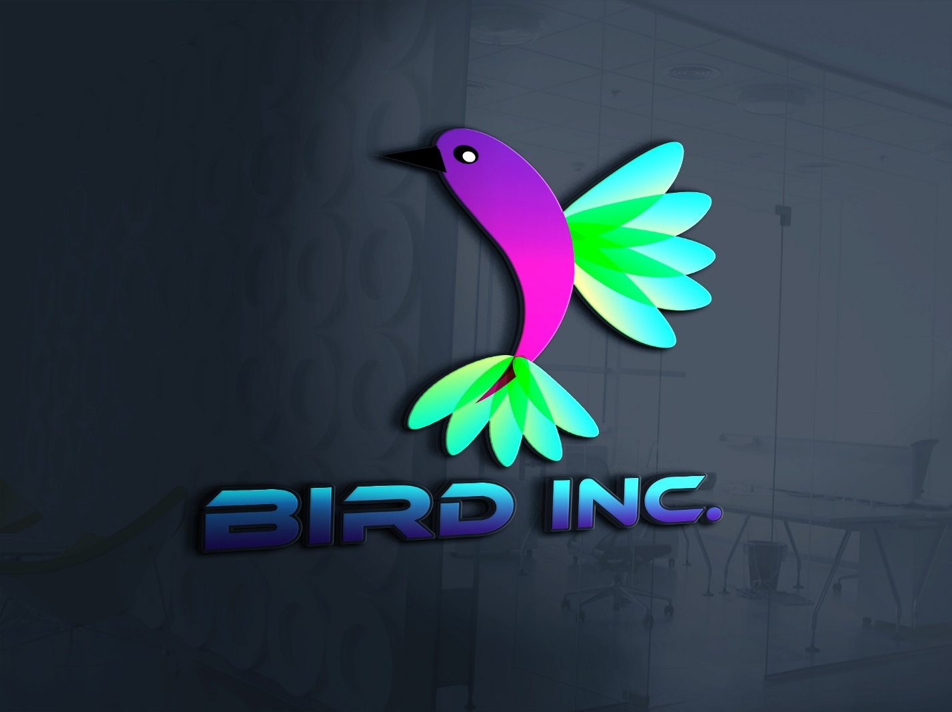
Project 3: She Wolf T-shirt Design
- New Document: Create a new document from file menu than new option
- Ellipse Tool: Use ellipse tool and make a round circle
- Fill & Stroke: Fill the circle and add a black stroke on circle
- Image Placement: Place wolf head inside the circle
- Text: Type text on circle
- Mockup: Place this design in mockup file
- Output: Save the image in JPEG format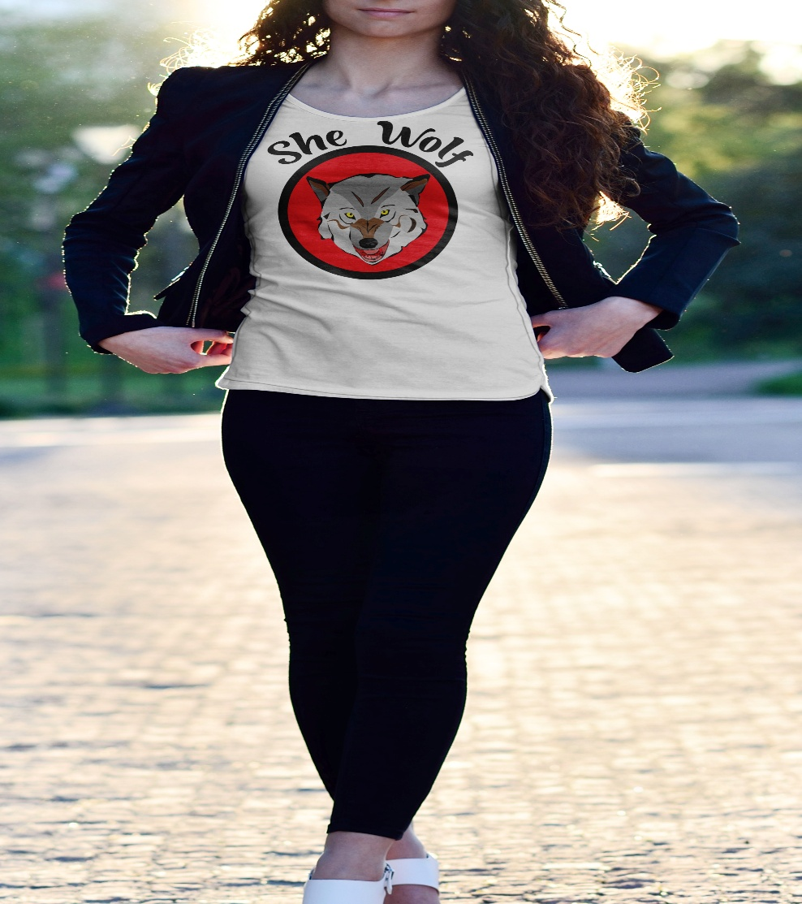

Project 4: Bottle Print Design
- New Document: Create a new document from file menu than new option
- Image: Place the juice splash image and apple image
- Custom Shape Tool: Use custom shape tool for creating crown and organic circle shape.
- Text: Type text on organic circle and create a new text for brand name
- Mockup: Place this design in mockup file
- Output: Save the image in JPEG format
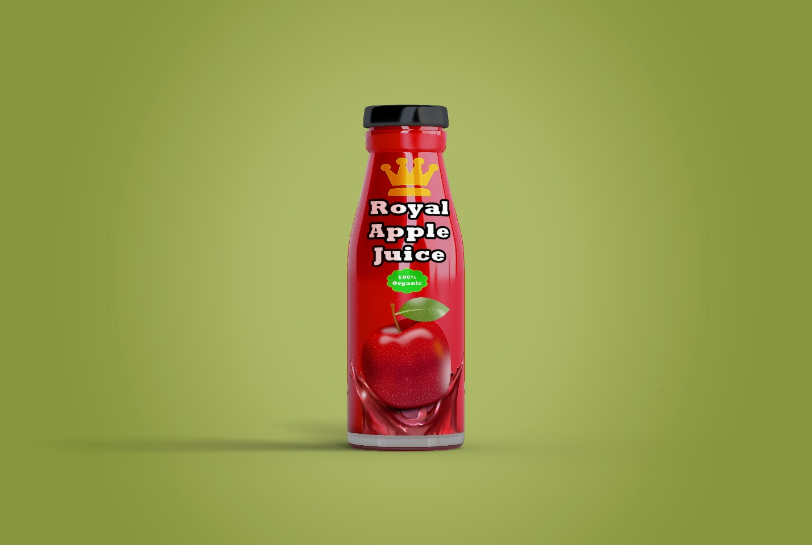

Project 5: Cover Design
- New Document: Create a new document from file menu than new option 820x312px
- Polygon Tool: Use polygon tool to create triangle shape. Make 5 triangle shape and place visually
- Image & clipping mask: Place images in tringle shape and create clipping mask.
- Stroke: Use different color stroke in triangles
- Background: Add an image for covering background
- Text: Type text for cover
- Social Media Icon: Place social media icons in cover
- Output: Save the image in JPEG format


