Lecture By Mahesh Sir |
Network security- SIEM
a Guide for soc analyst

Basic Terminology used in Networking

Exploit To enter/attack
Legitimate Genuine
Compromise Hacked
Mitigation To reduce effect
Remediation To prevent
Containment Controlling
Eradication Removal
Bypass Skip
Payload When data is sent over the Internet, each unit transmitted includes both header information and the actual data being sent. The header identifies the source and destination of the packet, while the actual data is referred to as the payload.
Asset People, property, and information. People may include employees and customers along with other invited persons such as contractors or guests. Property assets consist of both tangible and intangible items that can be assigned a value. Intangible assets include reputation and proprietary information. Information may include databases, software code, critical company records, and many other intangible items.
An asset is what we’re trying to protect.
Threat Anything that can exploit vulnerability, intentionally or accidentally, and obtain, damage, or destroy an asset.
A threat is what we’re trying to protect against.

Vulnerability Weaknesses or gaps in a security program that can be exploited by threats to gain unauthorized access to an asset.
Vulnerability is a weakness or gap in our protection efforts.

Risk The potential for loss, damage or destruction of an asset as a result of a threat exploiting vulnerability.
Risk is the intersection of assets, threats, and vulnerabilities.
Asset + Threat + Vulnerability = Risk.

Information Security

It can be of two types namely
- Application Security
Application security is the use of software, hardware, and procedural methods to protect applications from external threats.
The goals of application security are to protect the:
- Confidentiality of data within the application
- Availability of the application
- Integrity of data within the application

- Network Security – SIEM
Network security is the security provided to a network from unauthorized access and risks. It is the duty of network administrators to adopt preventive measures to protect their networks from potential security threats.

Types of Network Security Devices
- Active Devices
These security devices block the surplus traffic. Firewalls, antivirus scanning devices, and content filtering devices are the examples of such devices.
- Passive Devices
These devices identify and report on unwanted traffic, for example, intrusion detection appliances.
- Unified Threat Management (UTM)
These devices serve as all-in-one security devices. Examples include firewalls, content filtering, web caching, etc.
- Preventative Devices
These devices scan the networks and identify potential security problems.
For example
    - Penetration testing (P.T) devices:
Exploiting takes place. Tool used Metasploit.
    - Vulnerability assessment (V.A) appliances:
Manual (payload) SQL Quires.
Automation tool used Nessus, Nexpose.

Open Web Application Security project namely OWASP 10

Top 10 Vulnerabilities should be known for Analysis (Info resp. To 2017 list)-

1. SQL Injection: -Injection flaws, such as SQL, OS, and LDAP injection, occur when un-trusted data is sent to an interpreter as part of a command or query. The attacker’s hostile data can trick the interpreter into executing unintended commands or accessing unauthorized data.
- Injection can result in data loss or corruption, lack of accountability, or denial of access. Injection can sometimes lead to complete host takeover.

2. Broken Authentication and Session Management: - Application functions related to authentication and session management are often not implemented correctly, allowing attackers to compromise passwords, keys, session tokens, or exploit other implementation flaws to assume other users’ identities
- Such flaws may allow some or even all accounts to be attacked. Once successful, the attacker can do anything the victim could do. Privileged accounts are frequently targeted

3. XSS (Cross-site Scripting): XSS flaws occur whenever an application takes un-trusted data and sends it to a web browser without proper validation and escaping. XSS allows attackers to execute scripts in the victim’s browser which can hijack user sessions, deface web sites, redirect the user to malicious sites or possibly introduce worms, etc.
- Attackers can execute scripts in a victim’s browser to hijack user sessions, deface web sites, insert hostile content, redirect users, hijack the user’s browser using malware, etc.

4. Insecure Direct Object Reference: A direct object reference occurs when a developer exposes a reference to an internal implementation object, such as a file, directory, database record, or key, as a URL or form parameter. Attackers can manipulate those references to access other objects without authorization.

5. Security Misconfiguration: - Applications can unintentionally leak information about their configuration, internal workings, or violate privacy through a variety of application problems. Attackers use this weakness to steal sensitive data or conduct more serious attacks.
- Depends on the information, such flaws frequently give attackers unauthorized access to some system data or functionality. Occasionally, such flaws result in a complete system compromise.

6. Sensitive Data Exposure: * Insufficient Transport Layer Protection: Applications frequently fail to authenticate, encrypt, and protect the confidentiality and integrity of sensitive network traffic. When they do, they sometimes support weak algorithms, use expired or invalid certificates, or do not use them correctly.
- Such flaws expose individual users’ data and can lead to account theft. If an admin account was compromised, the entire site could be exposed.
*Insecure Cryptographic Storage: Web applications rarely use cryptographic functions properly to protect data and credentials. Attackers use weakly protected data to conduct identity theft and other crimes, such as credit card fraud.
- Failure frequently compromises all sensitive data that should have been encrypted

7. Missing Function Level access Control: Applications do not always protect application functions properly. Sometimes, function level protection is managed via configuration, and the system is misconfigured. Sometimes, developers must include the proper code checks, and they forget.

8. CSRF (Cross-site request Forgery): A CSRF attack forces a logged-on victim’s browser to send a forged HTTP request, including the victim’s session cookie and any other automatically included authentication information, to a vulnerable web application. This allows the attacker to force the victim’s browser to generate requests the vulnerable application thinks are legitimate requests from the victim.
- Attackers can cause victims to change any data the victim is allowed to change or perform any function the victim is authorized to use.

9. Using components with known vulnerabilities: Virtually every application has these issues because most development teams don’t focus on ensuring their components stay up to date. In many cases, the developers don’t even know all the components they are using, never mind their versions. Component dependencies make things even worse.

10. Unvalidated redirects and forwards: Applications frequently redirect to other pages, or use internal forwards in a similar manner. Sometimes the target page is specified in an unvalidated parameter, allowing attackers to choose the destination page.
Detecting unchecked redirects is easy. Look for redirects where you can set the full URL. Unchecked forwards are harder, because they target internal pages.
- Such redirects may attempt to install malware or trick victims into disclosing passwords or other sensitive information. Unsafe forwards may allow access control bypass.

Basics to know in Network security:
- IP’s
- Ports
- Protocols
- Traffic

1. IP (internet protocol) address:
It is a logical address used to communicate with other devices. It is a value of 32 bits/4 octets.
E.g.: 192.145.2.3
Range - 2^32 IPv4, 2^128 IPv6
Possibilities of IP addresses are 4.3 billion
Everyday internet using computers more than 10 billion
Assigning same IP address to 2 computers is not possible IP conflict happens, so IP address divided into 2 types
1. Public IP address
2. Private IP address

*Classes of public IP address and range
Class A 0.0.0.0-126.255.255.255
Class B 128.0.0.0-191.255.255.255
Class C 192.0.0.0-223.255.255.255
Class D 224.0.0.0-239.255.255.255
Class E 240.0.0.0-255.255.255.255
Note: 127.0.0.0-127.255.255.255 is a loop back address used for testing purpose.
*Classes of private IP address
Class A 10.0.0.0-10.255.255.255
Class B 172.16.0.0-172.31.255.255
Class C 192.168.0.0-192.168.255.255

Difference between public and private IP address
Public IP address | Private IP address
IP address issued by ISP  Routable worldwide  Registered /Paid | Issued by router for the host within its area  Non routable  Unregistered

Ports:
Port numbers is a unique id of protocols in a computer network
Ports are physical numbers use by TCP/IP to identify what services/application should handle data received by system.
TCP has 65536 ports i.e. 0-65535.
0-1023 are well known ports

Protocols:
A protocol is a set of rules and guidelines for communicating data.

TCP (Transmission control Protocol)
- Transmission control Protocol is used to establish communication between nodes or networks and exchange data packets. It guarantees delivery of data packets in the order they were sent.
- Hence it is most commonly used in all applications that require guaranteed delivery of data. It can handle both timeouts (if packets were delayed) and retransmission (if packets were lost).
- The stream of data is transmitted in segments.
- The segment header is 32 bit.
- It is a connectionless communication protocol at the third level (network) of the OSI model.
- TCP is a Transport layer in the OSI Model
- TCP protocol number is 6
- It is part of internet protocol suite commonly known as TCP/IP suite.

UDP (User Data Protocol)
- It is a communication protocol.
- It is normally used as an alternative for TCP/IP.
- However there are a number of differences between them. UDP does not divide data into packets. Also, UDP does not send data packets in sequence. Hence, the application program must ensure the sequencing.
- UDP uses port numbers to distinguish user requests.
- It also has a checksum capability to verify the data.
- UDP is a transport layer in the OSIMODEL
- UDP protocol number is 17
The following is a listing of some of the more common "well known" UDP ports:
Port Keyword Description
------ -------------- -----------------------------------------

15 NETSTAT What is the network status?

53 DOMAIN Domain Name Server

69 TFTP Trivial File Transfer Protocol

137 NETBIOS-NS NetBIOS name service

138 NETBIOS-DGM NetBIOS datagram service

161 SNMP SNMP network monitor

TCP Vs UDP
- TCP guarantees the delivery of data. On the other hand, UDP does not guarantee delivery of data.
- TCP delivers messages in the order they were sent. UDP has no ordering mechanisms.
- In TCP data is sent as a stream while UDP sends data as individual packets.
- UDP is faster than TCP.
- TCP is a connection oriented protocol while UDP is connectionless.

Network Time Protocol (NTP)
- It is a protocol that is used to synchronize computer clock times in a network of computers.
- NTP uses Coordinated Universal Time (UTC) to synchronize computer clock times to a millisecond, and sometimes to a fraction of a millisecond. UTC time is obtained using several different methods, including radio and satellite systems. Specialized receivers are available for high-level services such as the Global Positioning System (GPS) and the governments of some nations.
- NTP is an application layer in the OSI model
- NTP uses UDP port number 123.

FTP (File Transfer Protocol)
- It is a standard network protocol used to copy a file from one host to another over a TCP/IP-based network, such as the Internet.
- FTP is built on client-server architecture and utilizes separate control and data connections between the client and server applications, which solve the problem of different end host configurations (i.e., Operating System, file names).
- FTP is used with user-based password authentication or with anonymous user access.
- FTP is a TCP/IP protocol in the Application layer.
- FTP port number 21 is a reserved port in TCP/IP networking.
- FTP servers utilize port number 21 for protocol control messages.
- FTP data port number is 20 in TCP.
- FTP Control port number is 21 in TCP .
SSL (Secure Sockets Layer)
- It’s a standard security technology for establishing an encrypted links between a server and a client—typically a web server (website) and a browser; or a mail server and a mail client (e.g., Outlook).
- SSL allows sensitive information such as credit card numbers, social security numbers, and login credentials to be transmitted securely.
- SSL uses TCP port 443
- In the Internet Protocol Suite, TLS and SSL encrypt the data of network connections in the application layer. In model equivalences, TLS/SSL is initialized at layer 5 (session layer) and works at layer 6 (the presentation layer).

DNS (Domain name service)
- The DNS translates Internet domain and host names to IP addresses.
- DNS automatically converts the names we type in our Web browser address bar to the IP addresses of Web servers hosting those sites.
- DNS implements a distributed database to store this name and address information for all public hosts on the Internet.
- For example www.example.com might translate to 198.105.232.4
- DNS uses TCP for Zone Transfer over Port: 53
DNS uses UDP for DNS Queries over Port: 53
- DNS is an application layer service that uses UDP, which is part of the TCP/IP stack.

DHCP (Dynamic Host Configuration Protocol)
- A protocol for assigning dynamic IP addresses to device on a network
- When using the internet set of protocols (TCP/IP), in order for a computer system to communicate to another computer system it needs a unique IP address.
- Without DHCP, the IP address must be entered manually at each computer system.
- DHCP it is UDP port 67 & 68.
- DHCP is an Application protocol.

Why do we use DHCP?
Every device on a TCP/IP-based network must have a unique unicast IP address to access the network and its resources. Without DHCP, IP addresses for new computers or computers that are moved from one subnet to another must be configured manually; IP addresses for computers that are removed from the network must be manually reclaimed.
With DHCP, this entire process is automated and managed centrally. The DHCP server maintains a pool of IP addresses and leases an address to any DHCP-enabled client when it starts up on the network. Because the IP addresses are dynamic (leased) rather than static (permanently assigned), addresses no longer in use are automatically returned to the pool for reallocation.

HTTP (Hypertext Transfer Protocol)
- It’s an application protocol for distributed, collaborative, hypermedia information systems.
- HTTP is the foundation of data communication for the World Wide Web.
- Hypertext is structured text that uses logical links (hyperlinks) between nodes containing text.
- HTTP is the protocol to exchange or transfer hypertext.
- HTTP it is TCP port 80.
- HTTP is an Application layer.
For example: when you enter a URL in the browser this actually sends an HTTP command to the web server, directing it to fetch and transmit the requested webpage.
HTTPS (Hyper Text Transfer Protocol Secure)
- HTTPS is the secure version of HTTP, the protocol over which data is sent between your browser and the website that you are connected to. The 'S' at the end of HTTPS stands for 'Secure'. It means all communications between your browser and the website are encrypted. HTTPS is often used to protect highly confidential online transactions like online banking and online shopping order forms.
- Web browsers such as Internet Explorer, Firefox and Chrome also display a padlock icon in the address bar to visually indicate that a HTTPS connection is in effect.
- HTTPS uses TCP port number is 443.
- HTTPS is Application layer in OSI model.

How Does HTTPS Work?
HTTPS pages typically use one of two secure protocols to encrypt communications - SSL (Secure Sockets Layer) or TLS (Transport Layer Security). Both the TLS and SSL protocols use what is known as an 'asymmetric' Public Key Infrastructure (PKI) system. An asymmetric system uses two 'keys' to encrypt communications, a 'public' key and a 'private' key. Anything encrypted with the public key can only be decrypted by the private key and vice-versa.
As the names suggest, the 'private' key should be kept strictly protected and should only be accessible the owner of the private key. In the case of a website, the private key remains securely ensconced on the web server. Conversely, the public key is intended to be distributed to anybody and everybody that needs to be able to decrypt information that was encrypted with the private key.

What is a HTTPS certificate?
When you request a HTTPS connection to a webpage, the website will initially send its SSL certificate to your browser. This certificate contains the public key needed to begin the secure session. Based on this initial exchange, your browser and the website then initiate the 'SSL handshake'. The SSL handshake involves the generation of shared secrets to establish a uniquely secure connection between yourself and the website.
When a trusted SSL Digital Certificate is used during a HTTPS connection, users will see a padlock icon in the browser address bar. When an Extended Validation Certificate is installed on a web site, the address bar will turn green.

Why Is an SSL Certificate Required?
All communications sent over regular HTTP connections are in 'plain text' and can be read by any hacker that manages to break into the connection between your browser and the website. This presents a clear danger if the 'communication' is on an order form and includes your credit card details or social security number. With a HTTPS connection, all communications are securely encrypted. This means that even if somebody managed to break into the connection, they would not be able decrypt any of the data which passes between you and the website.

Benefits of Hypertext Transfer Protocol Secure
The major benefits of a HTTPS certificate are:
- Customer information, like credit card numbers, is encrypted and cannot be intercepted
- Visitors can verify you are a registered business and that you own the domain
- Customers are more likely to trust and complete purchases from sites that use HTTPS.
Traffic:
Traffic can be of 3 types
- Inbound - External to Internal.
- Outbound - Internal to External.
- Internal - Internal to internal.
Traffic can be detected based on IP’s.
 | Source IP | Destination IP
Inbound | Public IP | Private IP
Outbound | Private IP | Public IP
Internal | Private IP | Private IP
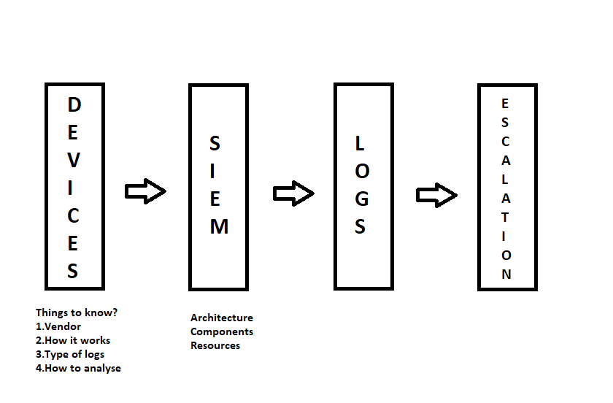
Devices:
- Firewall
- Email Gateway
- Antivirus
- AD servers
- IDS/IPS
- Proxy
- EPO
Firewall:
Vendor: Cisco, Checkpoint, Paulo Alto etc.
How it works:
It works based on the policies , it only allows genuine traffic and rejects malicious traffic.
Types of Policies
- Ports Monitoring
- Geo Location
- Source IP
- Destination IP
Types of logs:
- High Inbound Connections
- High Outbound Connections
- Policy changes
- Dropped connections
- Denied Connections
- Port Scans (Different connections observed with in no time)
- High Spike (It can be of 2 types i)False positive ii)Incident )
- Low Spike (It mostly occurs in low firewall)
Analysis:
- Event Count
- Time period
- Src IP
- Dest IP
- Port Number
- Geolocation
- Action (Allow or Deny)
- IP Reputation (Only In case of Public IP)
Websites to check IP Reputation:
https://www.talosintelligence.com/
https://www.ipvoid.com/
https://www.mxtoolbox.com/
https://www.blacklistmaster.com/
Escalation Process:
- SOP (Standard Operation Procedure) - Email, Tickets, Ping etc.
- SLA (Service Level Agreement) – Time required for event to analyse.
Email Gateway:
Vendor: Proof point, IronPort, McAfee.
What it checks:
- Sender
- Recipient
- Subject line
- Attachments
- URL’s
- Sender IP
- Sender Domain
Note: Spammer’s can be of 3 types
- Phishing - Through email false offers.
- Smishing - Through text SMS or WhatsApp.
- Vishing - Through Calls or Voice mails.
Types of logs:
- High Inbound Emails
- High outbound Emails
- Same Subject line
- Phishing -> Spear phishing (Targeting Key Persons)
- Spoofed Emails
Analysis:
- Sender
- Recipient
- Subject line
- Domain
- Sender IP (If public Check its reputation)
- Event count
- Time period
For URL’s reputation/Attachments Checking visit below site
https://www.virustotal.com/gui/home/upload
Note: For checking attachments, download attachments using “SAVE AS” option then without opening file check in above site.

IDS/IPS:
Vendor: Tipping Point.
How it Works:
IDS stands for Intrusion Detection System
IPS stands for Intrusion Prevention System
IDS works on Signatures and analyses Packets and allows genuine and blocks malicious traffic.
IPS helps in preventing all suspicious packets and gives information to administrators.
Type of logs/Analysis:
- SQL Injection (Breaking authentication using special characters attackers enter the Interface. for more details refer OWASP10)
- Remote code Execution (Attackers send some code to destination/targeted PC's. for more details OWASP10)
- Source IP (To avoid block them in firewall)
- Destination IP (To avoid block them in firewall)
- Event Count
- Time period
Active Directory AD Servers:
It Manage User Related Information.
Vendor: Microsoft
What it checks/Logs generated:
- Account Created
- Account Deleted
- User created
- User deleted
- Failed Logon
- Successful Logon
- Password Changes
- User lockout
- High Privileged Accounts (Who has all access)
Analysis:
- User Name
- IP address
- Host Name
Antivirus:
Antivirus/Anti-malware is a program used to prevent, detect, and remove malware/virus. Virus is nothing but a Set of code.
Vendor: McAfee (works on signatures and .files), Symantec.
What it checks/logs created:
- Virus Detected
- Virus Deleted/Removed
- Virus Quarantined(Virus detected but no action taken)
Analysis:
- User Name
- Host Name
- Virus Path
- Virus Name
ZERO DAY VULNERABILITIES:
A security vulnerability is a weakness/security hole in a product which not known to vendor.
ZERO DAY ATTACK/ EXPLOIT:
A security vulnerability is a weakness/security hole in a product which not known to vendor that allows attacker to exploit it.
EPO (E Policy Orchestrator):
Vendor: McAfee
It’s a centralised unit which collects all the logs from McAfee internally and we can also collect all device level information globally Such as virus related information, we can also check attachments and block them at EPO.
Proxy:
Vendor: Cisco (Scan safe)
- Proxy validates the domain info and redirects to client.
- It also checks the bandwidth of network
- We can also check logs in proxy
- Malicious outbound proxy – checks particular user when tries to enter malicious sites.
- We can check any domain related info
Analysis:
- Username
- Source IP
- Destination IP
- Domain Name
- Domain reputation
To check if URL redirects to suspicious sites and also checking status codes visit below link
https://urlscan.io/
Top 10 most referred status codes are
- Success:
200 - OK
201 - Created
204 - No Content
- Redirection:
304 - Not modified
- Client Error:
400 - Bad Request
401 - Unauthorised
403 - Forbidden
404 - Not found
409 - Conflict
- Server Error:
500 - Internal Server Error

SIEM (Security Information Event Management):
It is a centralised unit that collects all device logs within the Organisation.
Tools:
- HP ArcSight
- McAfee Nitro
- Splunk
- IBM Qradar
- RSA Envision
- Alienvault(AT&T)

HP ArcSight / Event Life Cycle / ArcSight Components:
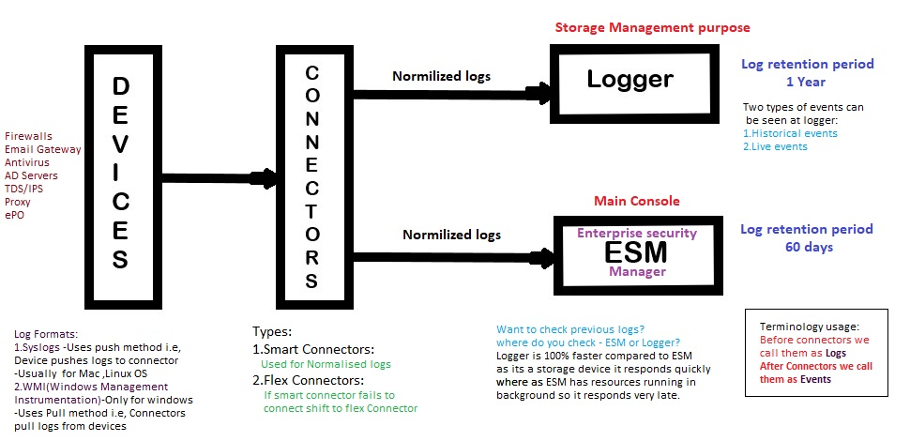
––––––––––––––––––––––––––––––––––––––––––––––––––––––––––––––––
Current Version: 7.0.0
Connectors collects logs and performs following activities
- Normalization: It is a process of separating/classifying similar kind of logs.
- Aggregation : Aggregation consolidates events with matching values into a single aggregated event, which reduces the number of events the Manager must evaluate
- Parsing: It is a process of converting unstructured format of logs into structured format nothing but it shows all event detail

Event categories:

Object | Application, Operating System ,Resource ,Router ,User
Behaviour | Access ,Authentication ,Authorization ,Execute, Modify
Outcome | Attempt ,Success ,Failure
Technique | Exploit, Brute Force, Code execution ,Scan ,Denial of Service
Device group | Firewall ,IDS ,VPN

Enterprise Security Manager (ESM):
Main resources include
- Active Channel - displays a stream of information defined by parameters set in the active channel
Types of Active Channels:
- Live Channels display continuously refreshed live event data
- Rules Channels display replay events for testing rules
- Resource Channels display the status of certain resources, such as the assets in your network model and open cases

- Dashboard – Graphical representation(Pie Charts) based on event ID’s(Firewall systems ,Virus Infected ,Failed login’s ,Email Gateway ,Top virus names)
- Made up of individual data monitors in a variety of graphical and tabular formats
- Summarize the event flow and communicate the effect of event traffic on specific systems on the network.
- Ideal way to see event data on your network in a variety of statistical views
- Cases – Creating Acknowledgement for information about a specific incident
- Cases are ESM's built-in trouble-ticket system.
- Cases are designed to stand alone within ESM or integrate with a third-party case management system, such as BMC Remedy
- Fields – Gives event information
- Filters - set of conditions that focus on particular event attributes
- Reports – Captured views or summaries of data that can be printed or viewed in the ESM Console
- A report binds one or more queries with a report template.
- Reports can also summarize data from Cases, Notifications, and Assets.
- Rules – Correlation rules are made using logical operators (AND OR NOT) and filters
- applied in many places in the event lifecycle by Smart Connectors, the Manager, and the correlation engine
- Used for monitoring, analysis, and reporting.
- Comes in three major forms.
  - Named filter resource
  - Unnamed filter resource
  - Inline filter resource
- Connectors
- Active list – Contains all ignored events which are differentiated base on correlation rules, most of the list contain events of High privileged accounts.

Phishing Email- Spoofed Email:

- We require Original email
- Header Analysis : total email info
In Outlook Go to File Menu > Properties > Select Header > check header analysis @ www.mxtoolbox.com
What do we check?
- Sender*
- Recipient
- Sender IP*
- Return Path* – if the reply mail not sent to sender
- Sender Domain*
- Subject Line
- Attachments* – check @ www.virustotal.com – Blocking can be done @ EPO ( IP’s, Url’s can also be blocked)
- Message ID’s – you will get to know original Id – we can know through IP
- Url’s* – Check @ www.Urlscan.io – Blocking can be done @proxy

*There are the parameter’s considered for Analysis

- Unintentional opening of URL’s or attachments go for a complete system scan
- After analysis if you feel suspicious the delete the mail from user Inbox.

