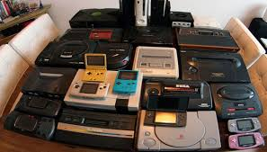

CARTUCHOS
https://www.youtube.com/watch?v=KpspFtEnbtU&list=PLNjLgsDAhW-MKkig1nz6wu8d_niAbuX2B
RESTAURACION
https://www.youtube.com/watch?v=UMHPVBOxIsE&list=PLKD2x-IQDV1kUoIsr1VjdepgBji4WtSZZ
REPARAR CONSOLAS
1
https://www.youtube.com/watch?v=ppWUlzOIWtc&list=PLioOqHaBo6ZO5f3YElqhjy1jY4DuIBbLS
2
https://www.youtube.com/watch?v=ZBUMxrxOAUc&list=PLioOqHaBo6ZOnjBjBraReOwoUA4FFDxSk
3
https://www.youtube.com/watch?v=PPGPTwxX9mA&list=PLmLhyDEUsw_k0p40MYKM5B5M6bOX2w7EF
4
https://www.youtube.com/watch?v=rNM6YjXWE4g&list=PLGF1yGhnNdAh-5bh_UfBGUtTqWwl2dRlj
5
https://www.youtube.com/watch?v=MXlIiK1oogQ&list=PLdb6VRwmS8OLi-tDnb-d7i5DhBzOqOrwx
6
https://www.youtube.com/watch?v=1OpgiECSG4o&list=PLh2f6rAi16sqA71uX1PFqP3a3SLC0cKSJ

